**FINAL PROJECT EXAM**

**WEB DESIGN(ACTHUM)**

**SUBMITTED BY:**

**LAZARO, Le Ann A.**

**SUBMITTED TO:**

**Ma’am PASCUAL, JOANA ROSE**

**TABLE OF CONTENT**

1. Description of the Shop………………………………1
2. My Personal Logo Design……………………………3
3. My Background Design………………………………4
4. My Wire framing Website Structure…………………5
5. Overall Summary of the Wire Framing…………….13
   1. Home Pages
   2. Shop Pages
   3. Categories
   4. About Us
   5. Contact
   6. Cart
6. Final Output of the Website……………………….…17
   1. Index/Register………………………………………...17
   2. Home……………………………………………….….18
   3. Shop…………………………………………………...20
   4. Categories………………………………………….....21
   5. About Us………………………………………….…...23
   6. Contact………………………………………………...24
   7. Cart………………………………………………….…24
   8. Add to Cart………………………………………….…25
   9. Receipt…………………………………………………26
   10. Product Description…………………………………...26
7. My Refinement and Changes of Website Journal…27

**Lauwie Online Shop**

**Description of the Shop**

“Lauwie Online Shop, your ultimate destination for high-quality cosplay costumes, accessories, and art merchandise.

We are passionate about bringing your favorite characters to life with premium costumes, handmade props, and exclusive fan art.

Online shopping apps have transformed the way we shop, offering unparalleled convenience and accessibility and making it easier than ever to find exactly what you need.”

The Lauwie Shop website is an online shopping platform dedicated to selling cosplay items, such as costumes, props, wigs, and footwear. It is structured to provide a user-friendly and visually engaging experience for visitors, with an emphasis on showcasing various products related to anime and gaming characters.

 It is where customers can explore a wide selection of cosplay related products. The layout is designed to be clean and organized, making it easy for visitors to browse and find what they’re looking for. The products are displayed in a grid format, allowing several items to be viewed at once, each with clear images, product names, prices, and an “Add to Cart” button.

The shop mainly focuses on items that are popular in anime and gaming cosplay culture. This includes:

**Costumes** – High-quality outfits such as the Raiden Shogun Costume from Genshin Impact or Cure Prism Costume from magical girl anime. These are made with attention to detail for fans who want to dress like their favorite characters.

**Wigs** – Colorful and character-accurate wigs like the Mavuika Wig and Xilonen Wig, designed to match specific characters. These are important for completing any cosplay look.

1

**Props** – The shop also offers props such as the Weiss Schnee Sword, which are used as accessories or for photo shoots to enhance cosplay realism.

**Footwear** – Custom-made boots like MTO Xilonen Boots and Mavuika Boots ensure comfort and character accuracy.

Each product in the shop is clickable, leading to a separate page with more information and images. This helps customers learn more about the product before buying. The prices are listed in Philippine Pesos (₱), which shows that the shop caters mainly to a Filipino audience, though it could appeal to international cosplay fans as well.

A unique feature of the shop is the Add to Cart Confirmation Modal. When a user clicks the “Add to Cart” button, a pop-up asks them to confirm their action. This adds an extra layer of user-friendliness, preventing accidental purchases and giving the customer time to think.

2

**MY PERSONAL LOGO DESIGN**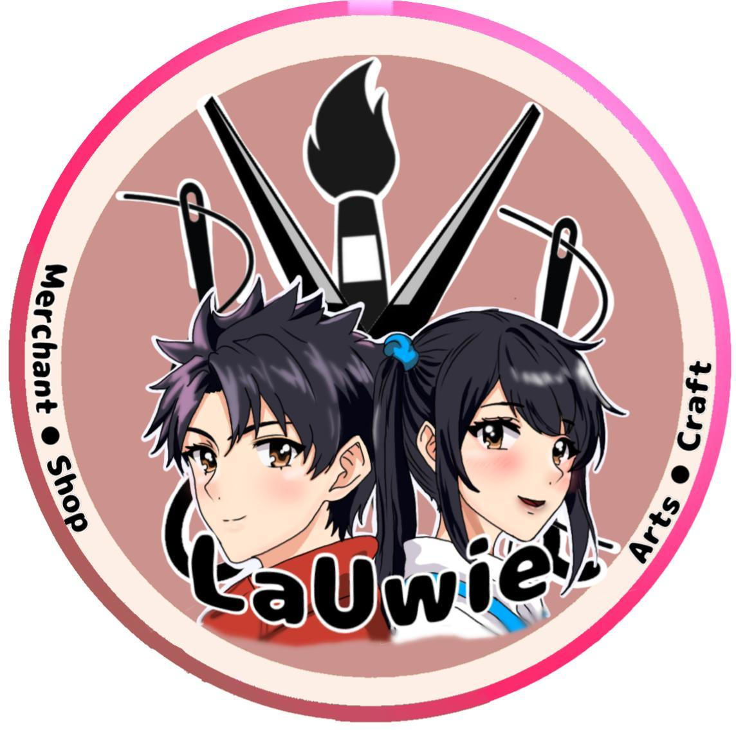

First, I created my personal logo name “Lauwie” which is the name of my current Online Shop on Fb. The Logo embodies creativity, artistry and an entrepreneurial mindset with every element contributing to its overall significance. The two figures represent youthful innovation, and a contemporary outlook, attracting an audience that appreciates artistic expression.

The artistic tool such as a paint brush, scissors and sewing needles underscore the skill and creativity inherent in the business, highlighting its commitment to handmade and varied products the wording which “merchant, arts, craft and shop,” emphasize the brand's dedication to artistic goods and handmade crafts merging creativity with commerce.

The lively color palette combination of brown, light brown radiant pink and mixed color pink and brown result in energy and professionalism, fostering a welcoming and dynamic environment. Collectively the logo represents a brand that honors art and craftsmanship turning passion into high-quality and tangible goods.

3

**MY BACKGROUND DESIGN**

This background features an elegant and calming watercolor composition dominated by soft pink, blush, and neutral tones. The central focus is a delicate arrangement of cherry blossom flowers, gracefully branching out across the canvas.

  The flowers vary in shades of white, soft pink, and blush, with fine details such as thin black stems and subtle floral accents adding depth and a naturalistic feel. Dark leaves contrast gently with the light blossoms, creating a balanced composition. The background transitions smoothly between warm pink gradients and cool gray tones, giving it a dreamy, flowing appearance.

This blend of hues enhances the overall softness and elegance, making it ideal for websites with a refined, artistic, or nature inspired aesthetic. The background matches the color of my logo which the color of light pink will be attractive to the user or viewer.

4

**My Wire framing Website Structure**

* **Home Pages**

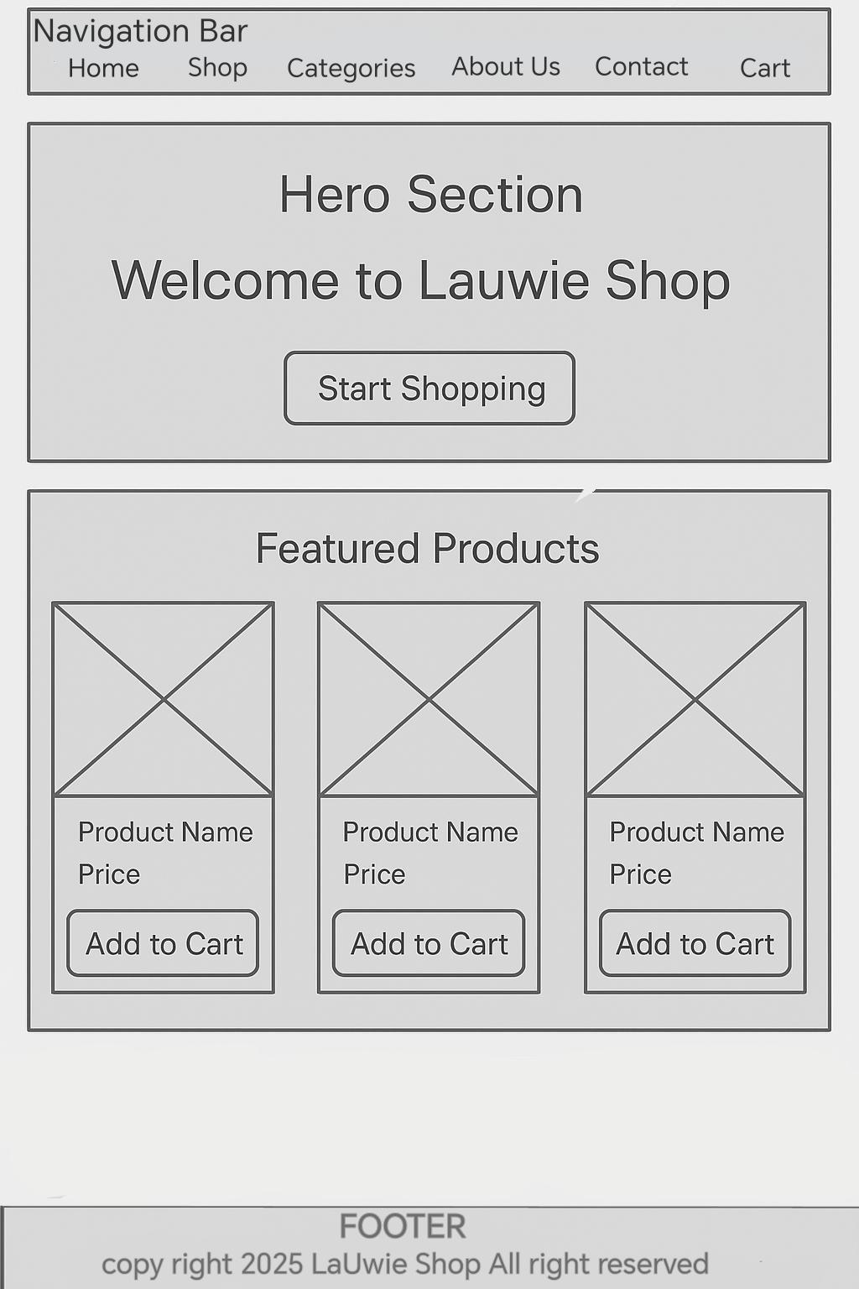

5

* **Shop Pages**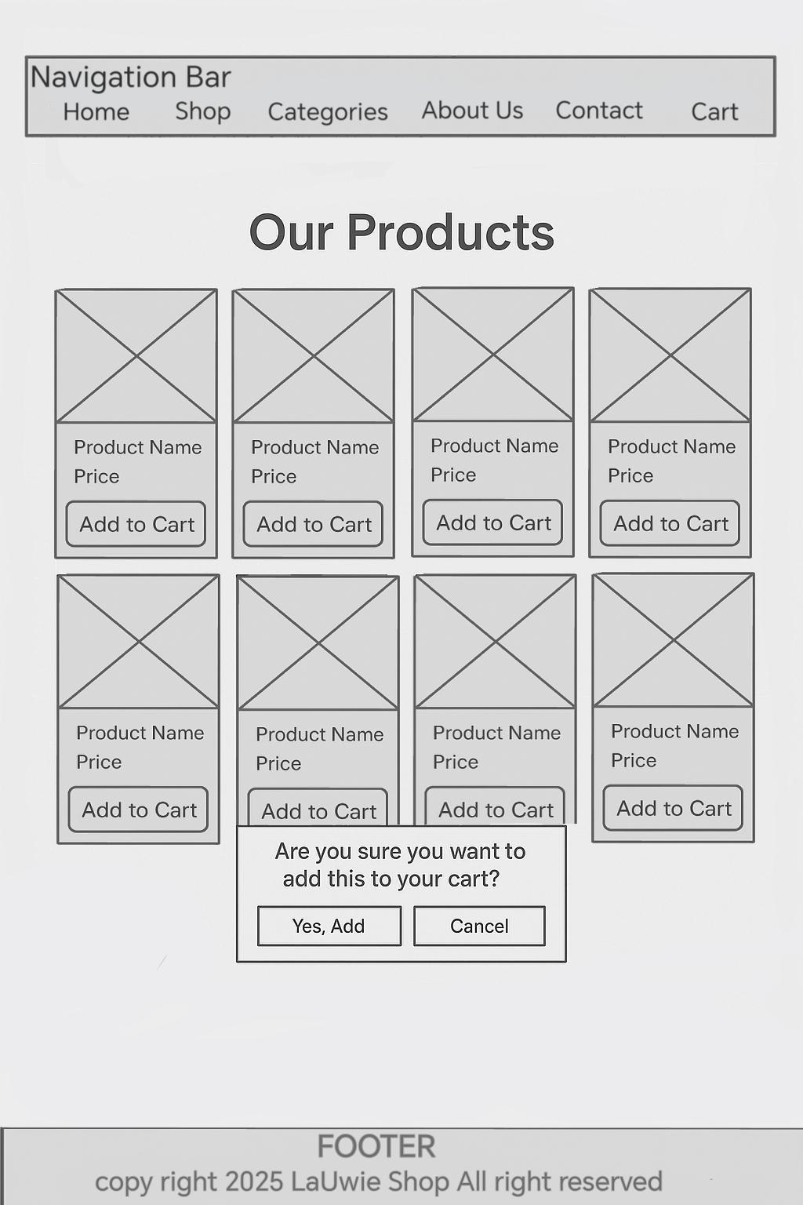

6

* **Categories Pages**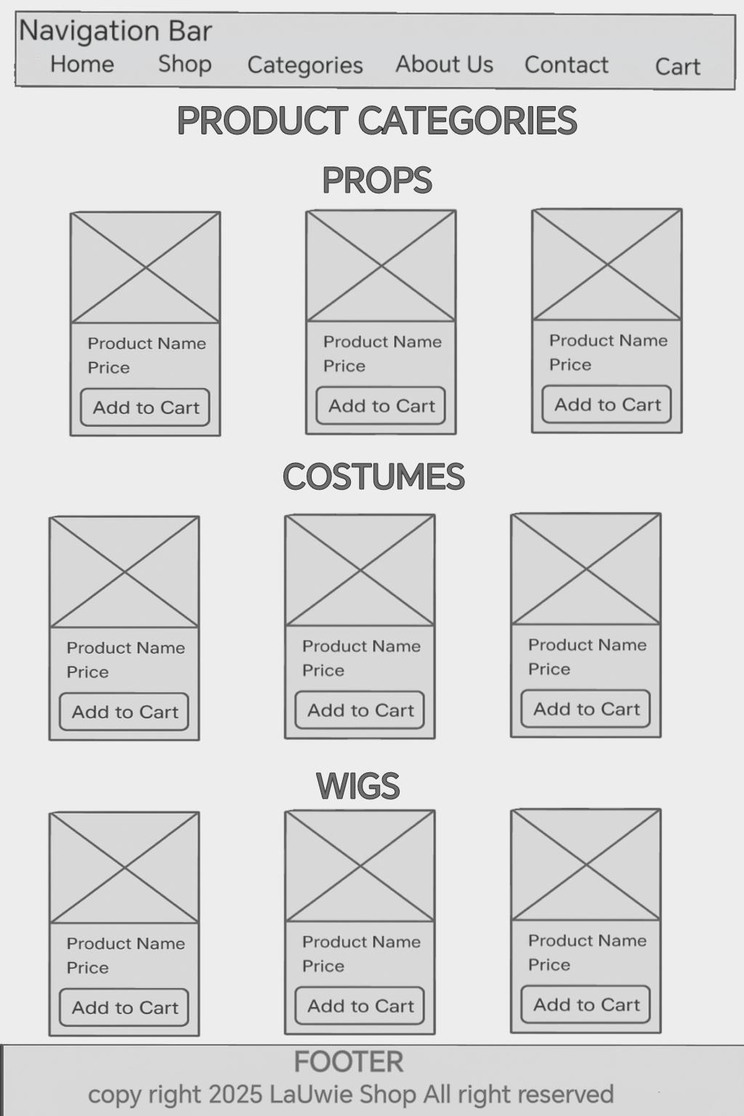

7

* **About Us Pages**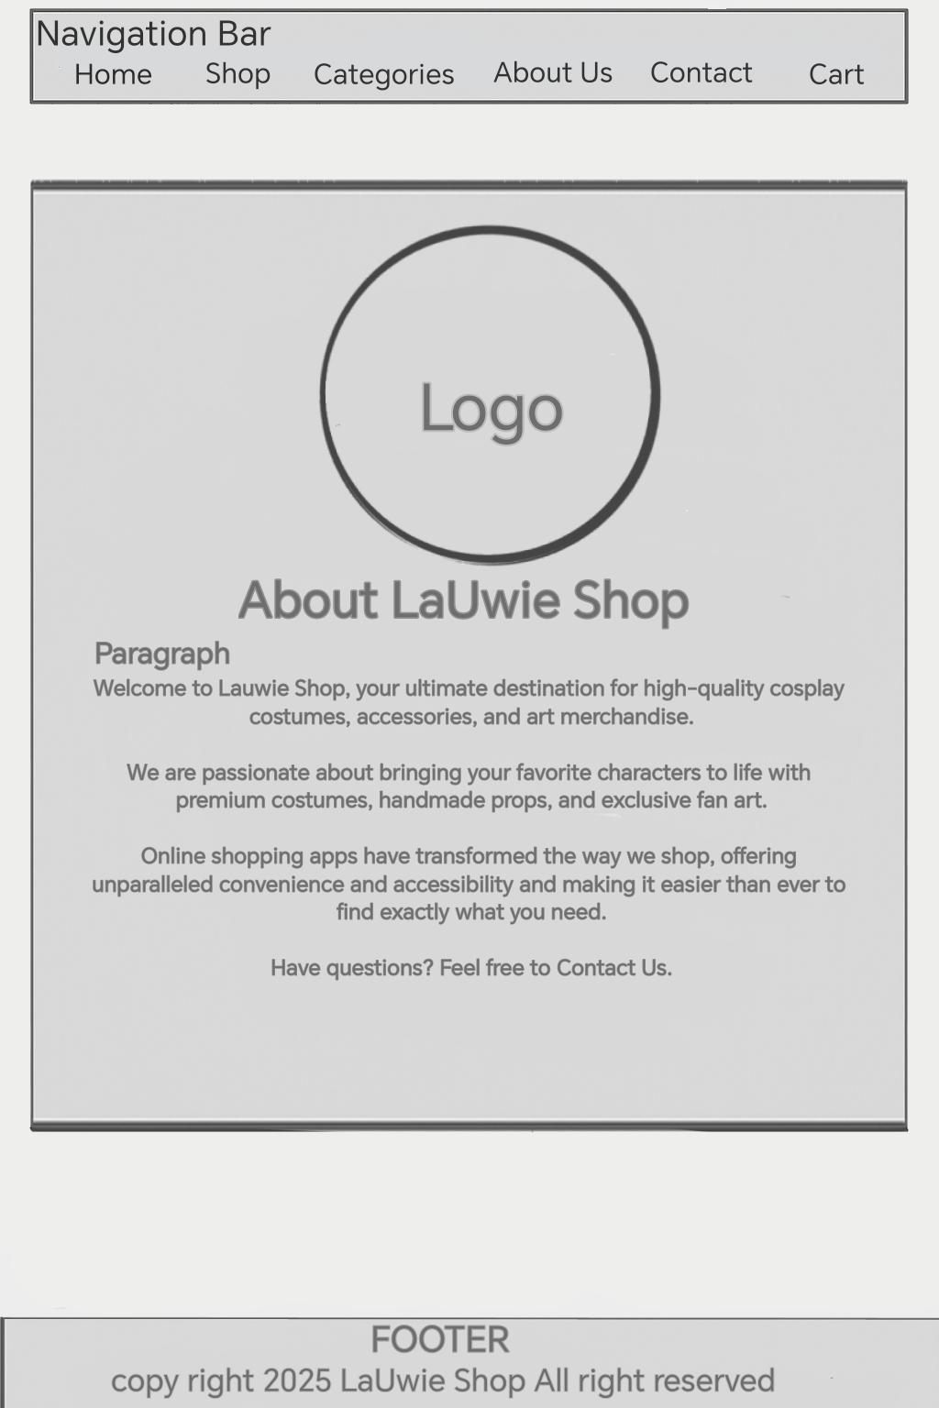

8

* **Contact Pages**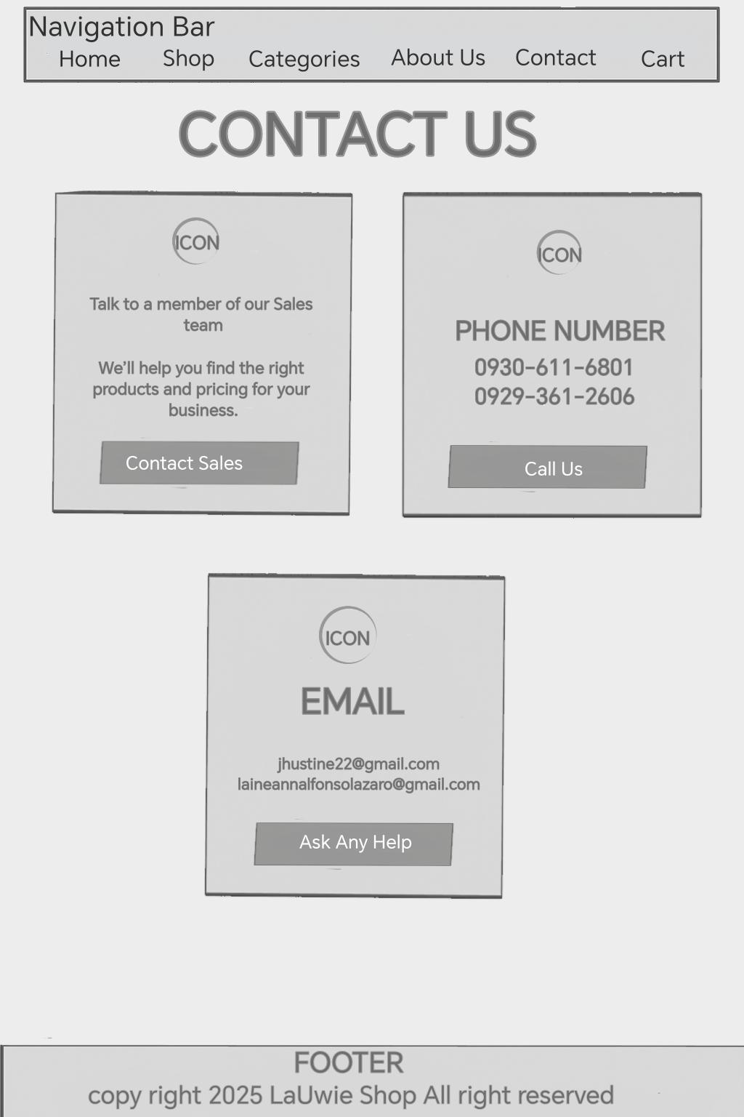

9

* **Cart Pages**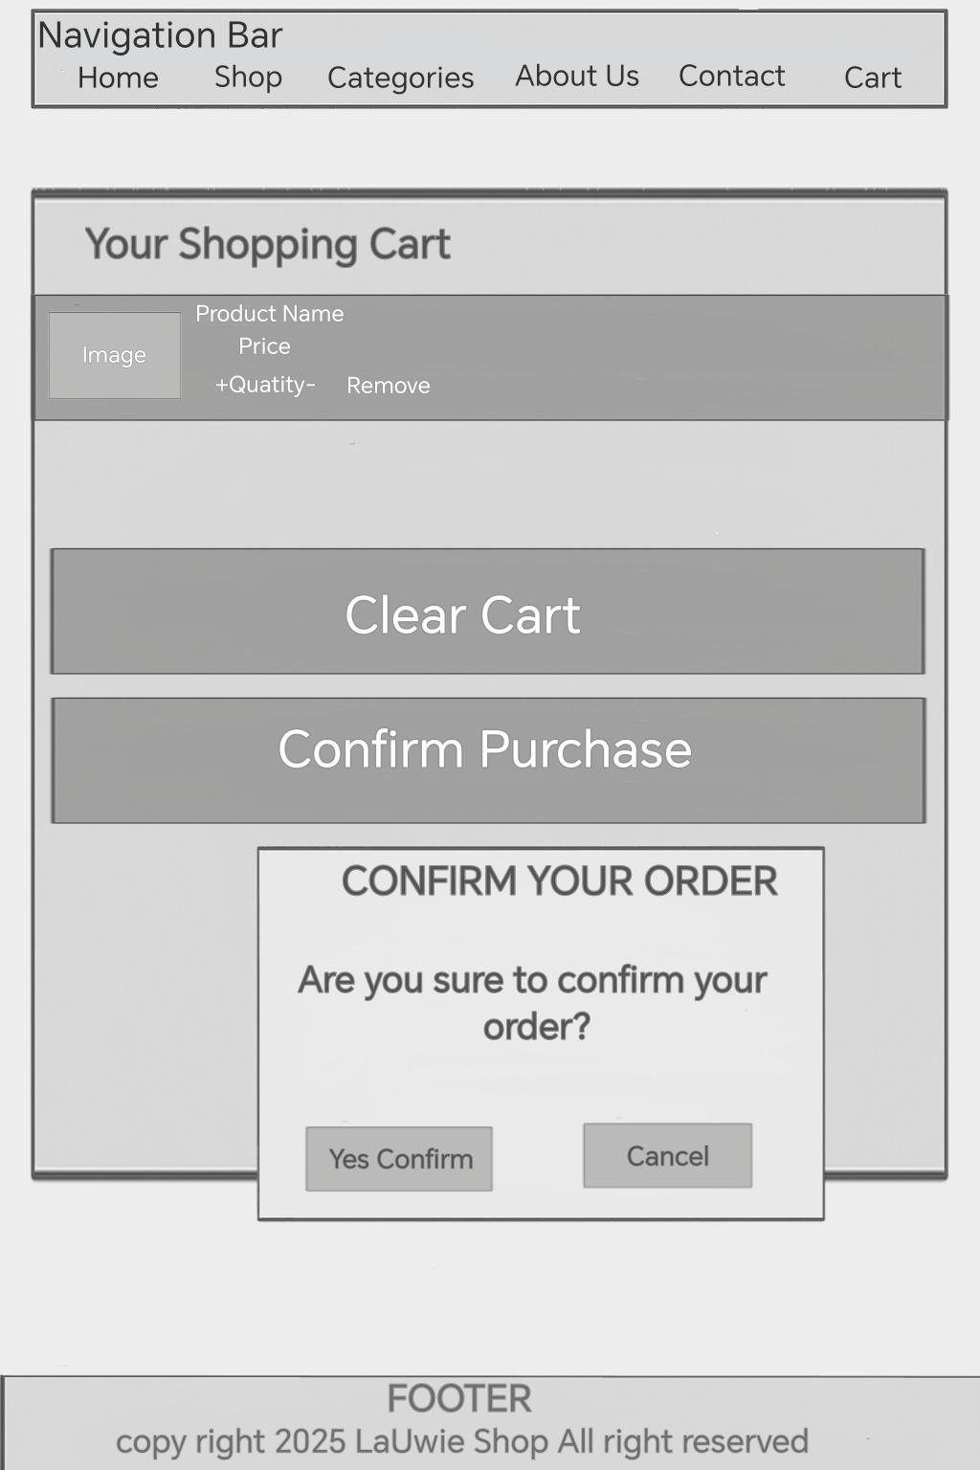

10

* **Receipt**

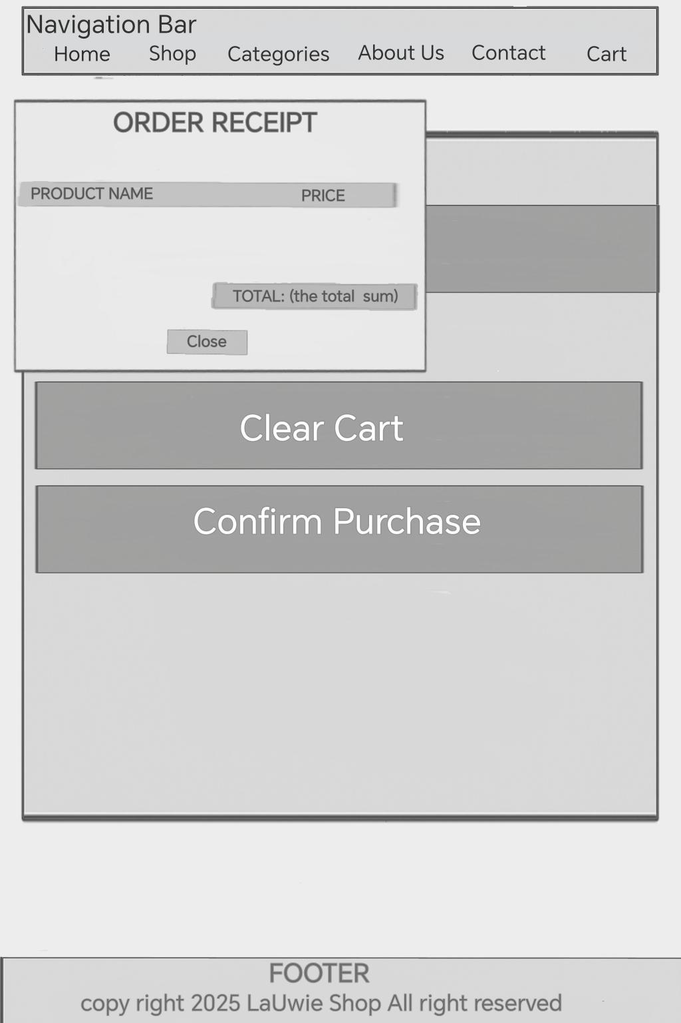

11

* **Product Description**

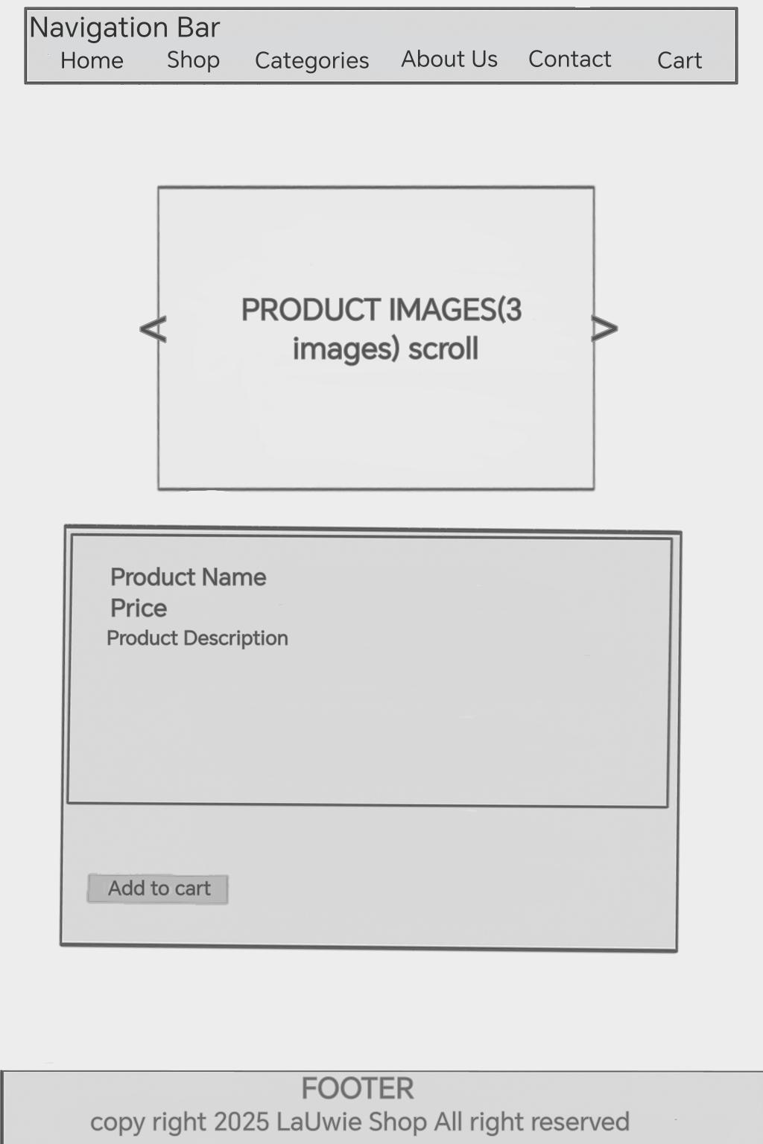

12

**OVERALL SUMMARY OF THE WIREFRAME**

**Pages and Navigation Structure**

Before I started coding, I drew a simple wireframe of how I wanted my site to look. I included parts like the navigation bar, the logo, a welcome section, product listings, and a footer. This helped me imagine how everything would be arranged on the website. (See the wireframe from the first images).

|  |  |  |
| --- | --- | --- |
| **PAGE NAME** | **FILE** | **DESCRIPTION** |
| 1. Home | index.html | Landing page with intro, featured products and brand |
| 1. Shop | shop.html | Display all available products with prices and “Add to Cart” options. |
| 1. Cart | cart.html | View items added to the cart and proceed to checkout. |
| 1. About us | about.html | Brand story mission and team |
| 1. Contact | contact.html | Contact form, social media and customer support info. |
| 1. Categories | categories.html | To view the different product where they belong “Props”,” Wig” and “Costume”. |

13

1. **Home Page**

* **Hero section:**

-Title: “Welcome to Lauwie Shop”

-Button: “Start Shopping”

* **Featured Products:**

-Display three products slots with placeholder (product name, price, button:” Add to Cart”)

* **Footer**

-Copyright notice for 2025

1. **Product Categories Page**

* **Categories Overview:**

-Section for Props Costume, and Wigs

-Each section contains products sloth with (Product Name Price -button: “Add to Cart”)

* **Footer**

-Similar copyright notice

1. **Products Page**

* **Product Listing**

-A grid layout displaying multiple products with (Product Name Price button: “Add to Cart”)

* **Confirmation Modal**

-Prompt: Are you sure you want to add this to your cart?” with “Yes add” and “Cancel” options

1. **About Us page**

* **About Section:**

-Includes a placeholder for a logo

-Text introducing LaUwie Shop and its commitment to quality

14

* **Footer**

-Same copyright notice

1. **Shopping Cart page**

* **Cart Overview**

List of Product added to the cart with

-Image placeholder

-product Name

-Price

-Quality adjustment options and a “Remove” button

* **Buttons**

- “Clear Cart”

- “Confirm Purchase”

* **Confirmation Medal**

-Prompt:” Are you sure to confirm your order?” with “Yes Confirm”

 and cancel.

* **Footer**

Same copyright notice

1. **Receipt page**

* **Order Receipt**

-Display confirmed product names and prices and a total summary.

-Button: “Close”

* **Footer**

**-**same copyright notice

1. **Product Details Page**

* **Product Info:**

-Scrollable section for product images/

-Detailed information Including:

-Product name

-Price

-Description

15

* **Button**

- “Add to cart”

* **Footer**

- “Same as other pages”

1. **Contact Us Page**

* **Contact Information:**

-Section for sales contact, phone numbers and emails addresses.

-Actionable buttons for “Contact Sales,” Call Us” and “Ask Any Help”

* **Footer**

-Same copyright notice

16

**FINAL OUTPUT OF THE WEBSITE**

**INDEX/REGISTER**

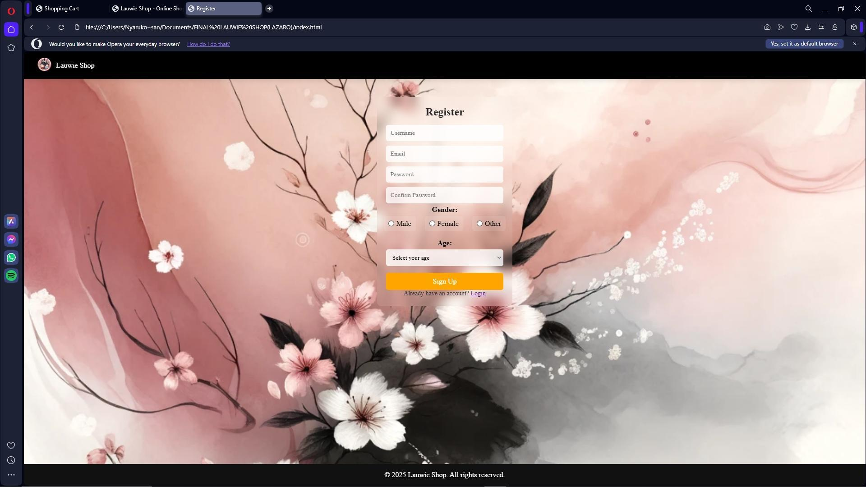

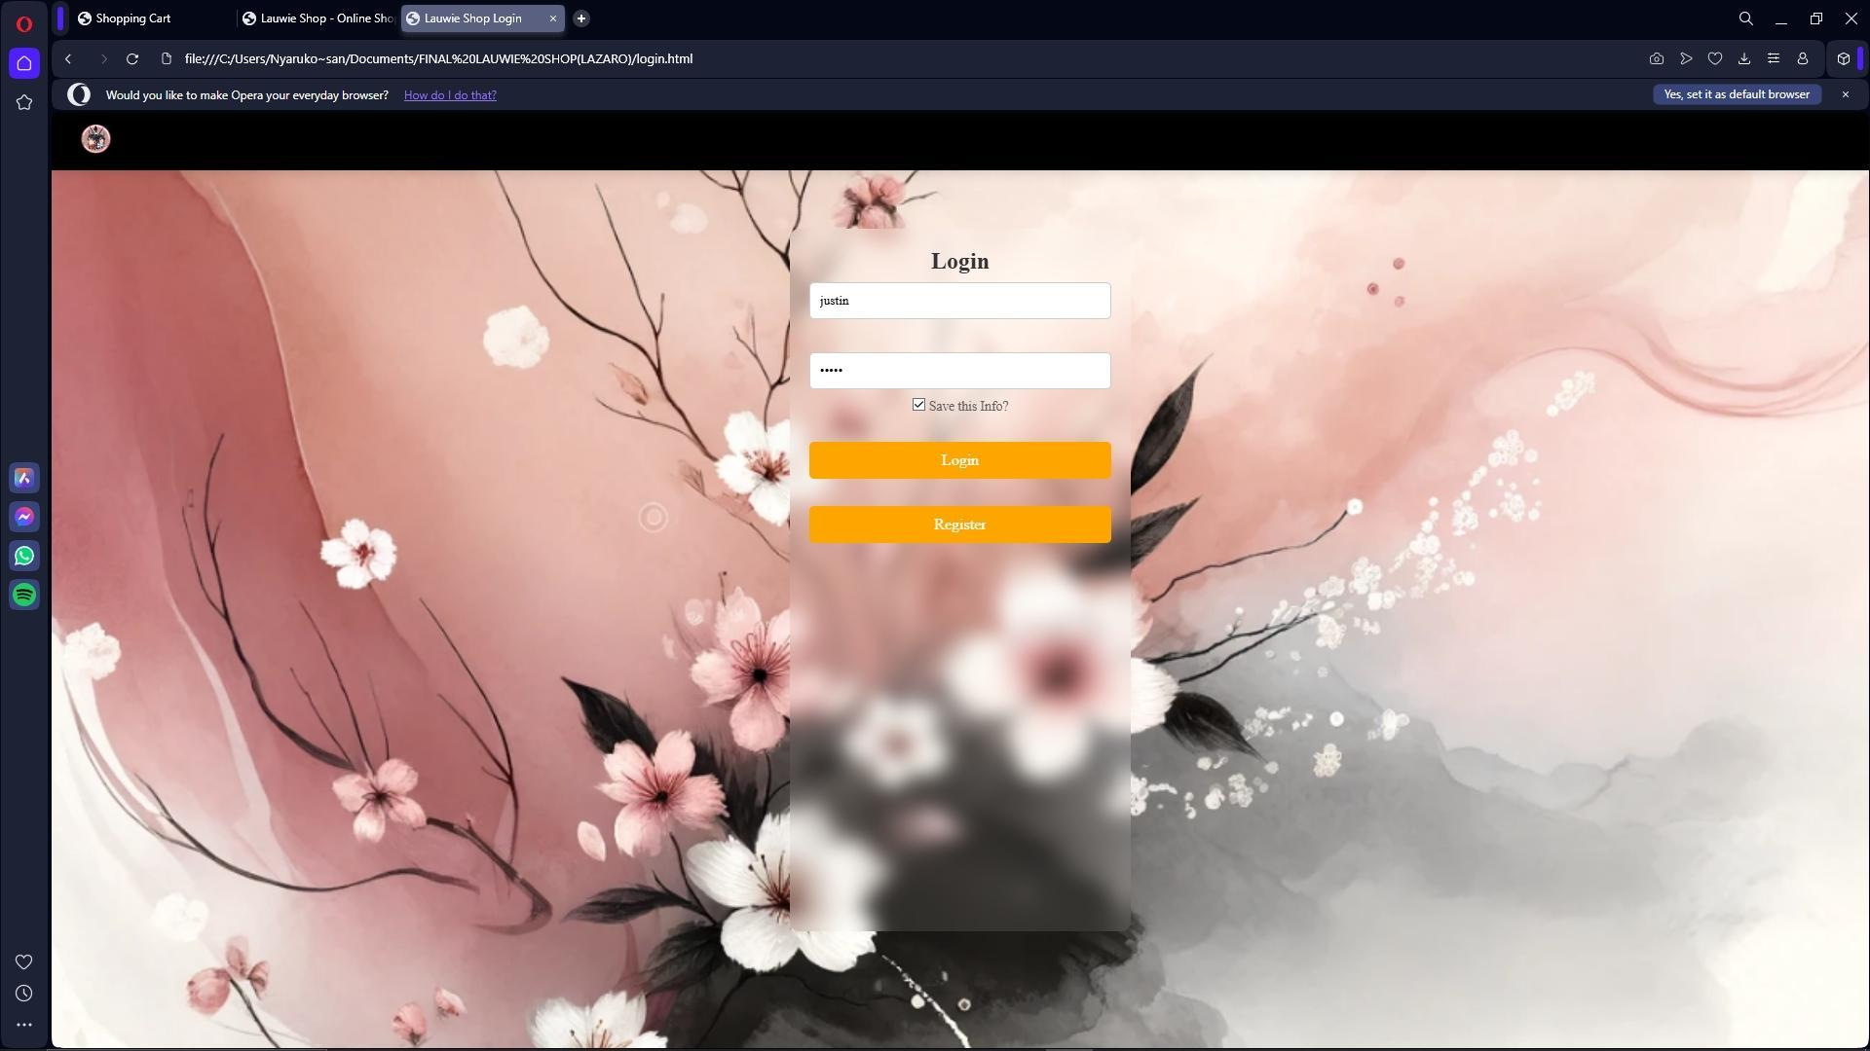

17

**HOME**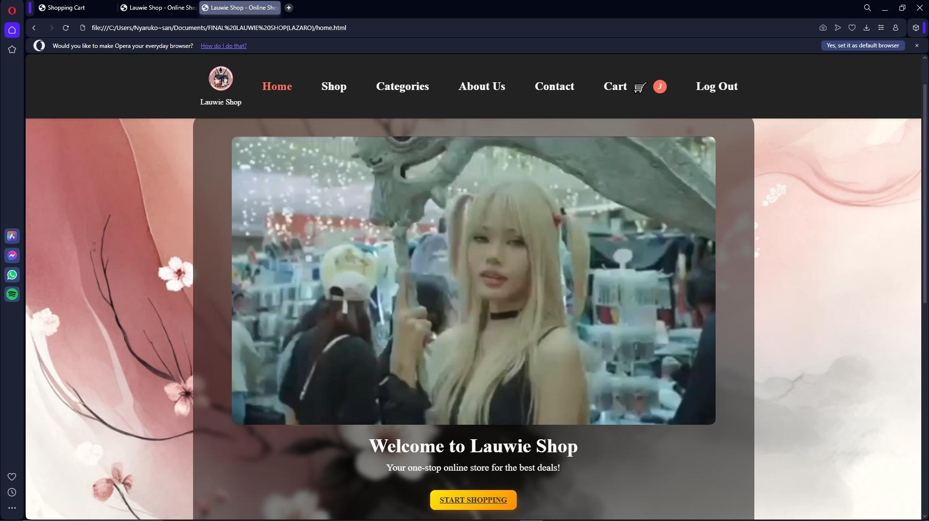

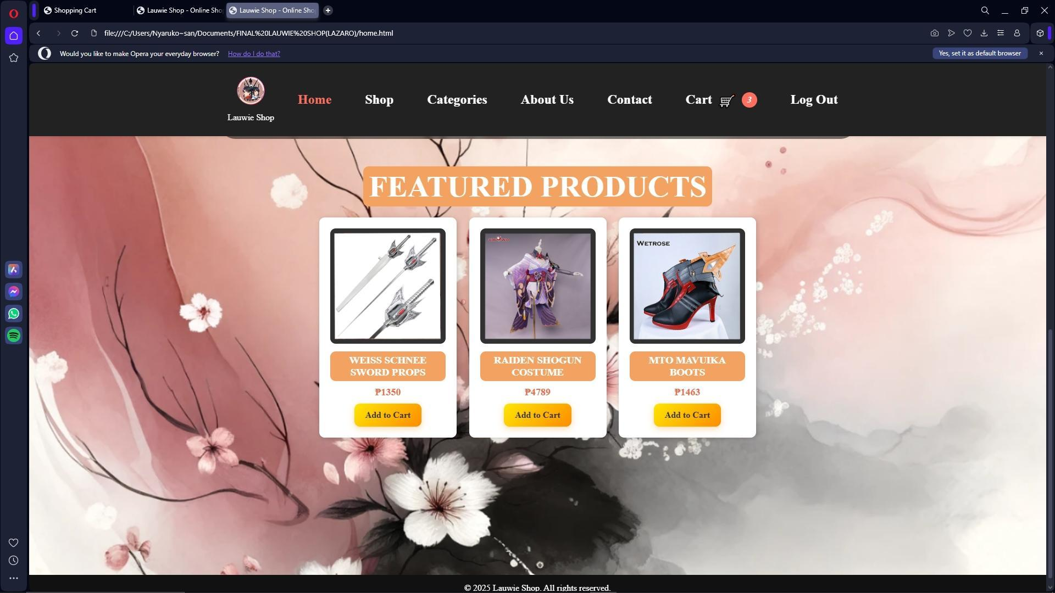

18

This is my final website that I created. The Homepage has a clean layout with a navigation bar at the top, which lets you explore different parts of the site like the SHOP, CATEGORIES, ABOUT US, and CONTACT sections. I even added a cart icon that will eventually show the number of items when people and stuff right now, it just for show but I plan to add functionality of each picture of a product. I included a clip that adds a more personal and lively touch, almost like introducing people to what Lauwie Shop is all about in a visual way. The background features soft, floral artwork to keep the vibe warm and creative, which really matches the kind of items I want to sell. There’s still a lot to do, like adding the actual product listings and making it mobile-friendly.

The video was originated shots by Toy con which many cosplayers show case their own costume and act the character they like.

19

**SHOP**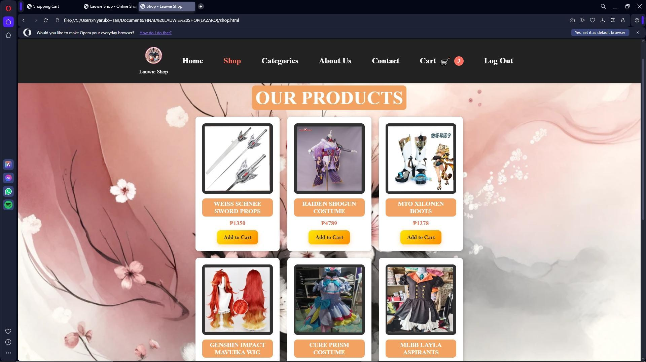

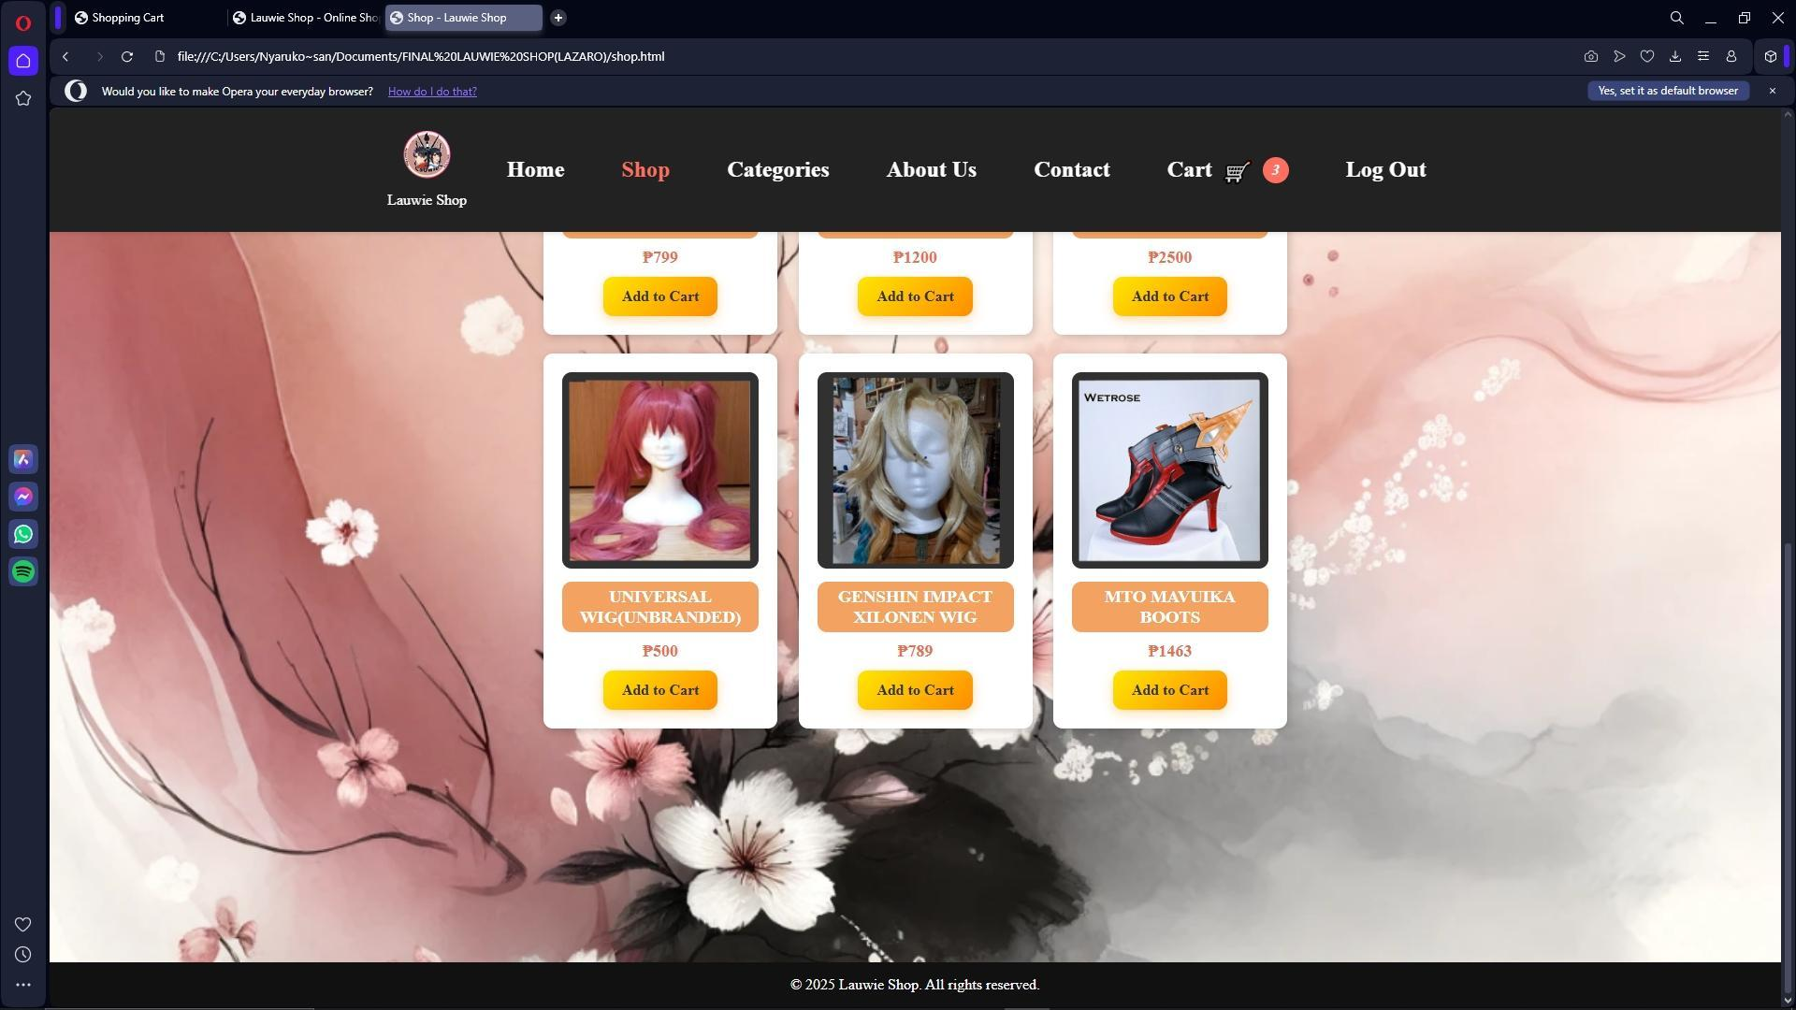

20

I designed it to be simple but visually engaging, with a clear "OUR PRODUCTS" heading to grab attention. Each item is placed in its own card, showing an image, name, price in pesos, and a bright yellow “Add to Cart” button. I wanted it to feel like a real online store, so I included various cosplay-related items, such as the Weiss Schnee sword props, Raiden Shogun costume, and Genshin Impact wigs. Each product has its own little space with consistent styling, making it easy for people to browse and get interested in what they see. I kept the background theme soft and floral, similar to the homepage, to maintain a warm and artsy aesthetic that fits my brand’s personality.

**CATEGORIES**

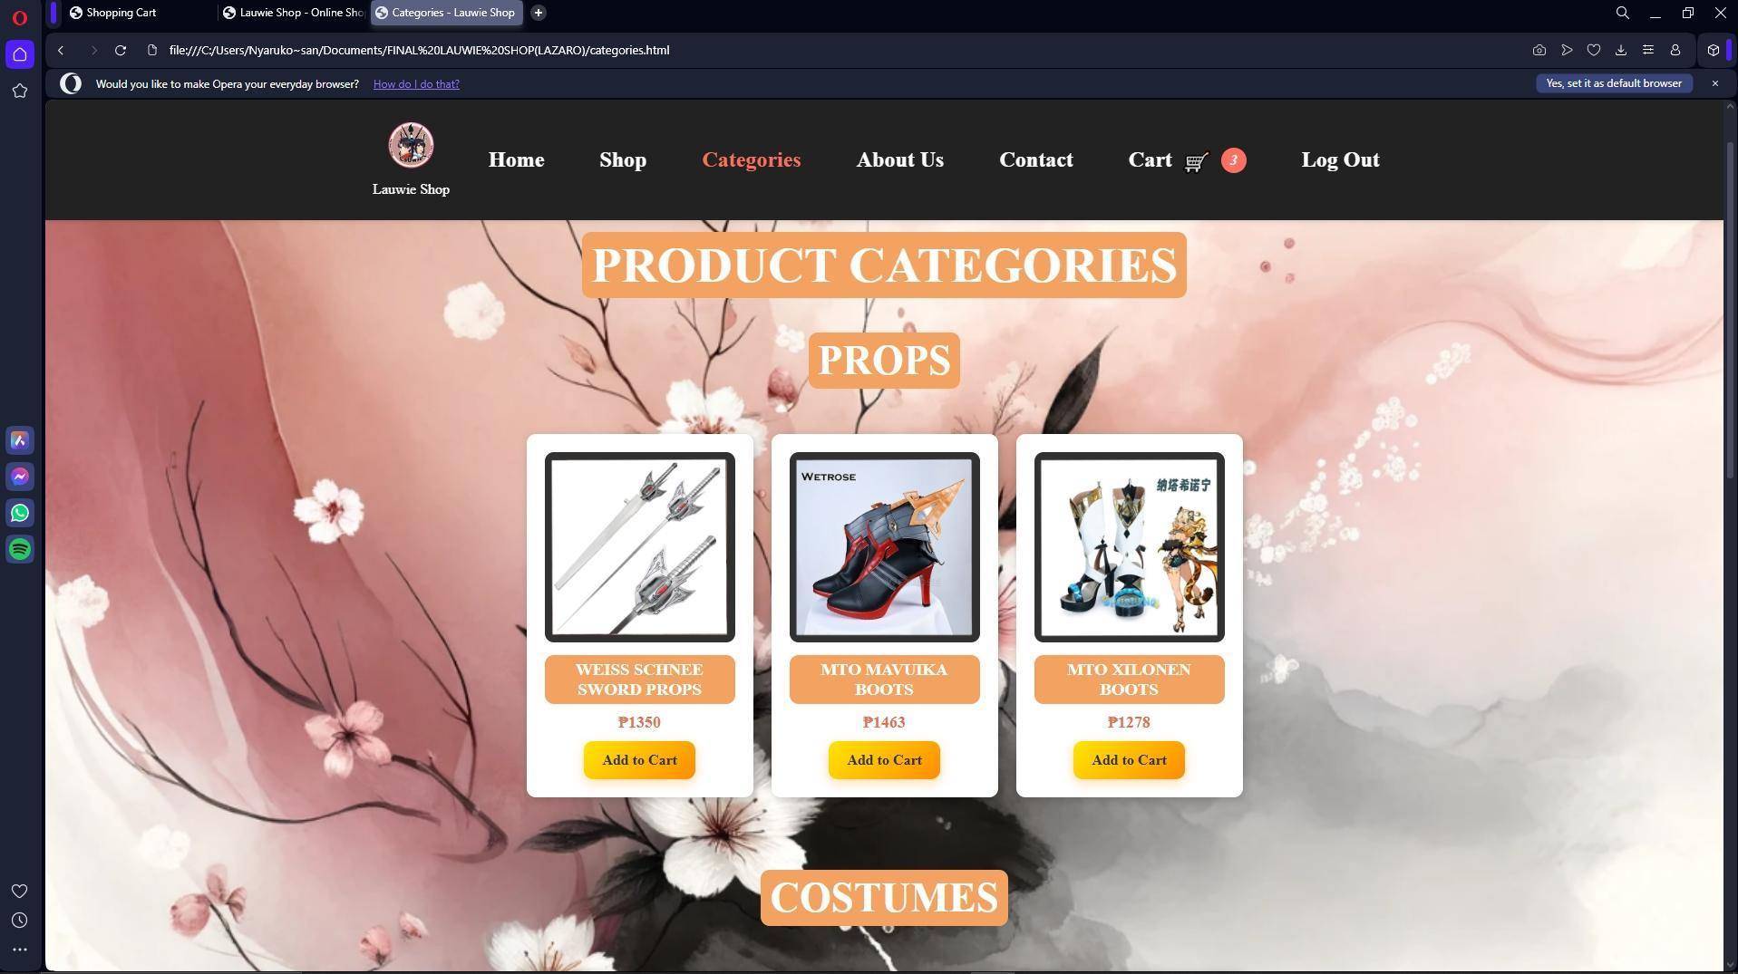

21

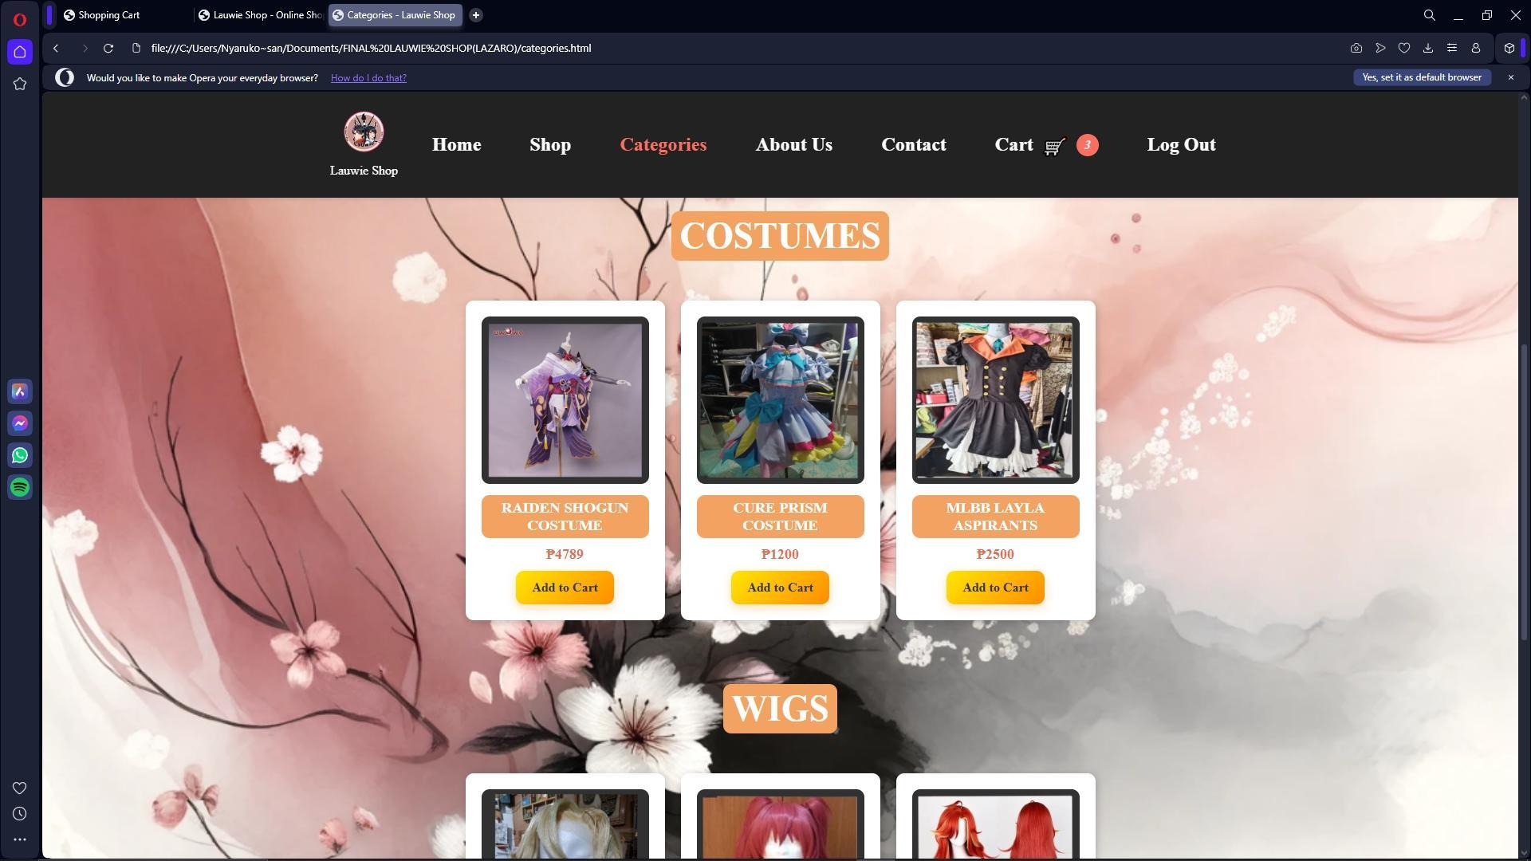

I organize all the products into easy-to-browse groups. I wanted this page to feel clean and simple, so I used big, bold headings like “PRODUCT CATEGORIES” followed by labels such as “PROPS” and “COSTUMES” to guide customers through the page. Under each category, I’ve displayed the relevant items in a neat grid layout. For example, under “PROPS,” I included things like the Weiss Schnee Sword Props, MTO Mavuika Boots, and MTO Xilonen Boots. Each product card follows the same design as the Shop page image, name, price, and a bright yellow “Add to Cart” button. The goal was to make it easy for users to find exactly what type of items they're looking for without having to scroll through everything all at once.

22

**ABOUT US**

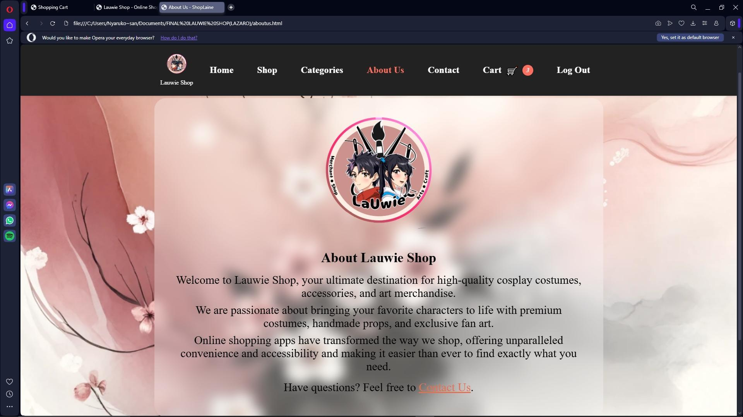

I also created the Page “About us” which it will explain about the purpose and what is the website showing for. I created an introduction that explain about the Lauwie Shop. “At Lauwie Shop, we are passionate about bringing your favorite characters to life through premium costumes, handmade props, and exclusive fan art. Our goal is to provide fans and creatives with unique items that celebrate their love for fandoms. As online shopping continues to evolve, we strive to offer a seamless and enjoyable experience, combining convenience with accessibility to help you find exactly what you need with ease.”

23

**CONTACT**

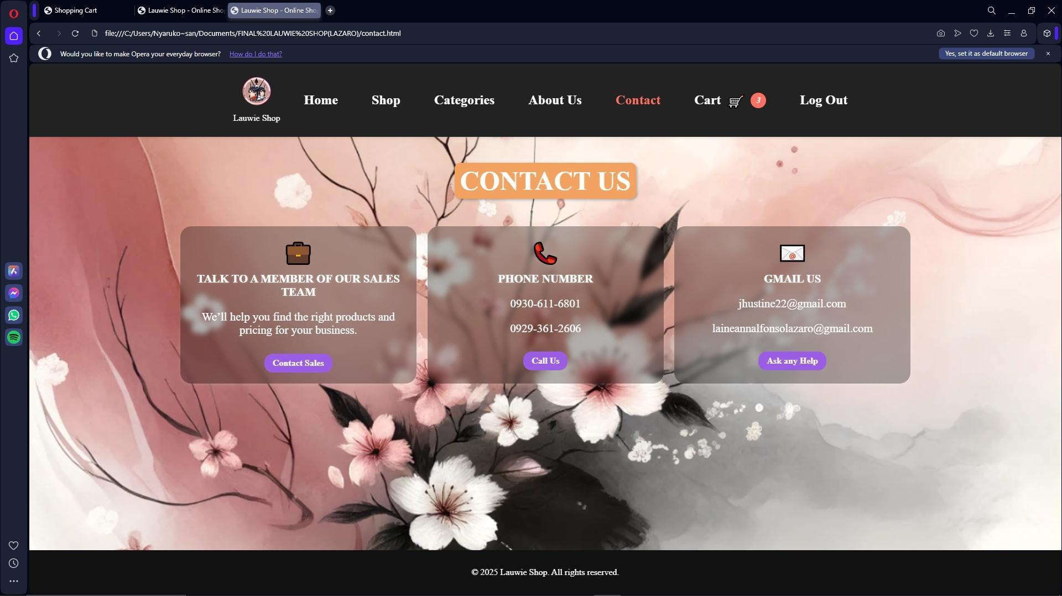

From the Contact Page, I added the three contact which is the out-contact number, Online link Sale and Google or private Gmail for asking about the services. From the Contact Page, I added the three contact which is the out-contact number, Online link Sale and Google or private Gmail for asking about the services.  
  
**CART**

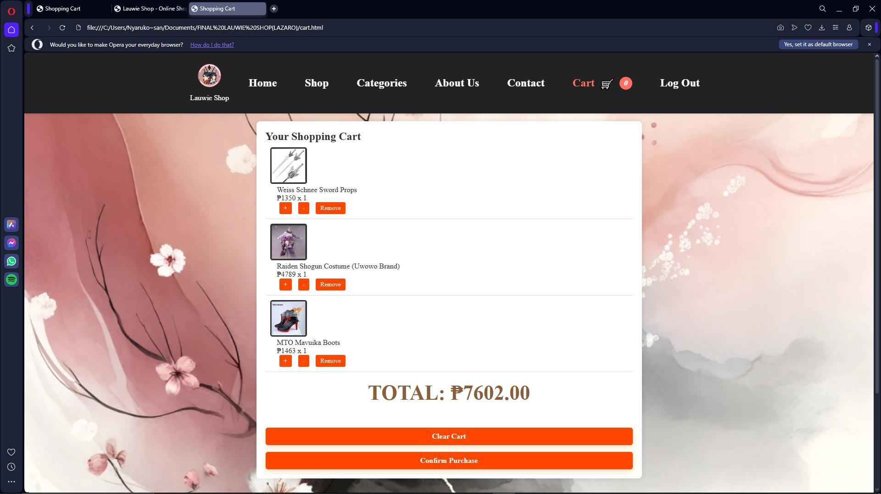

24

The Shopping Cart page of Lauwie Shop serves as the final step before purchase, allowing customers to review and manage the items they intend to buy. Each product listed in the cart includes its name, image, price in Philippine Peso, and quantity, along with options to increase or decrease the number of items or remove them entirely. The total amount due is automatically calculated and displayed at the bottom, ensuring transparency for the buyer. Two action buttons— “Clear Cart” and “Confirm Purchase”—allow users to either empty the cart or proceed with finalizing their order.

**ADD TO CART**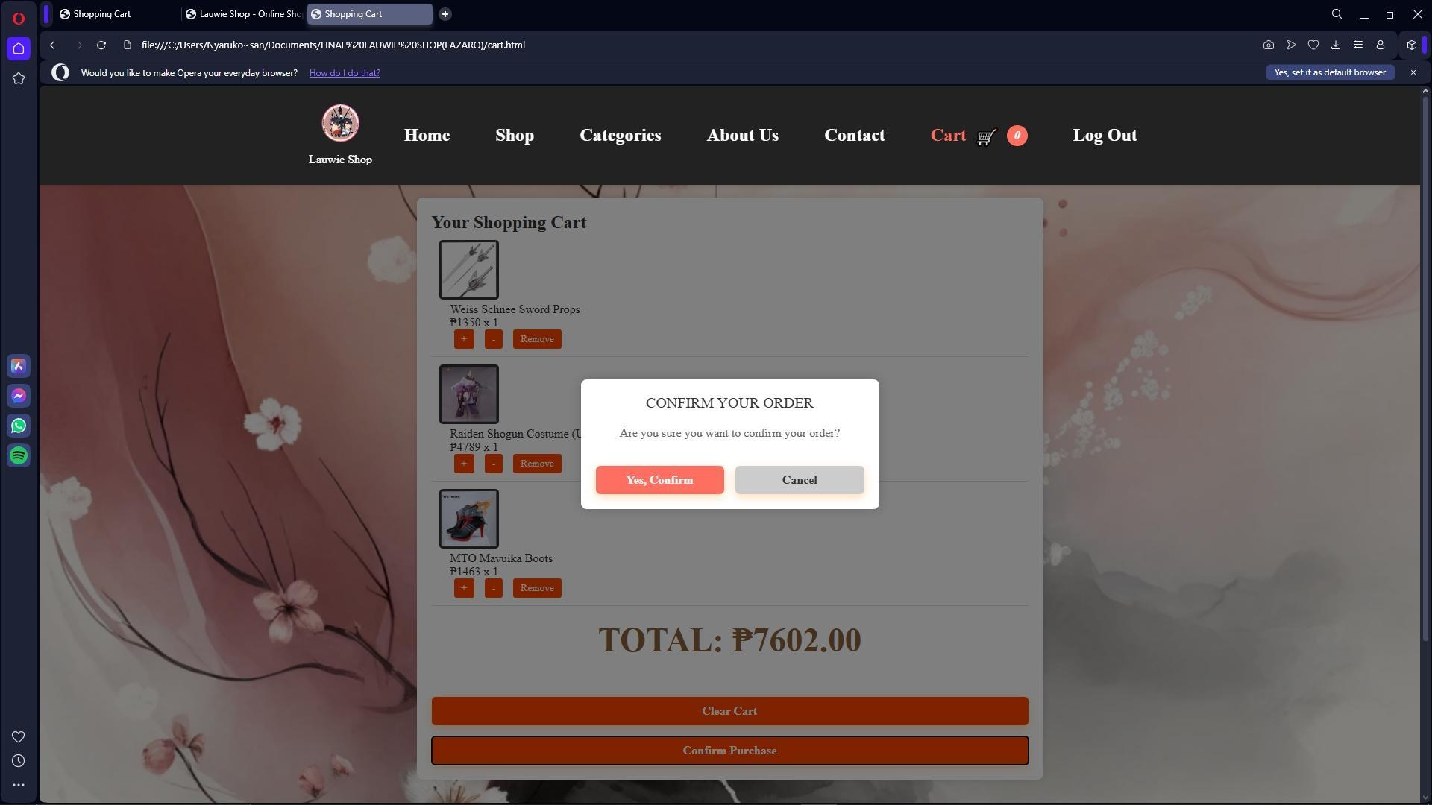

This is where you will add your item that you like to buy. I also created this so that if I will add something at least I have two options if “cancel “or “Yes, add”.

25

**RECEIPT**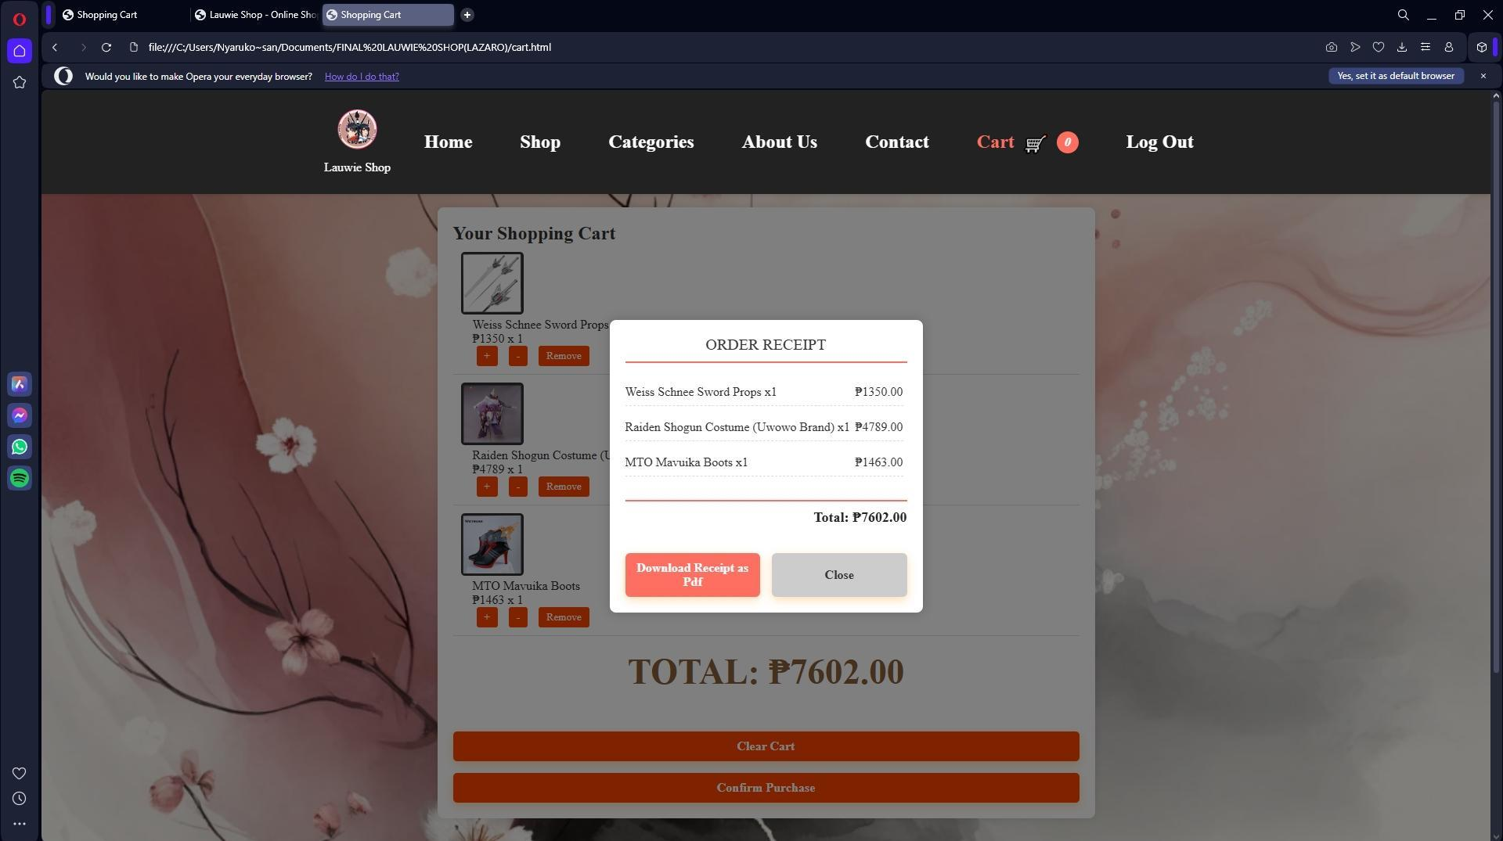

**PRODUCT DESCRIPTION**

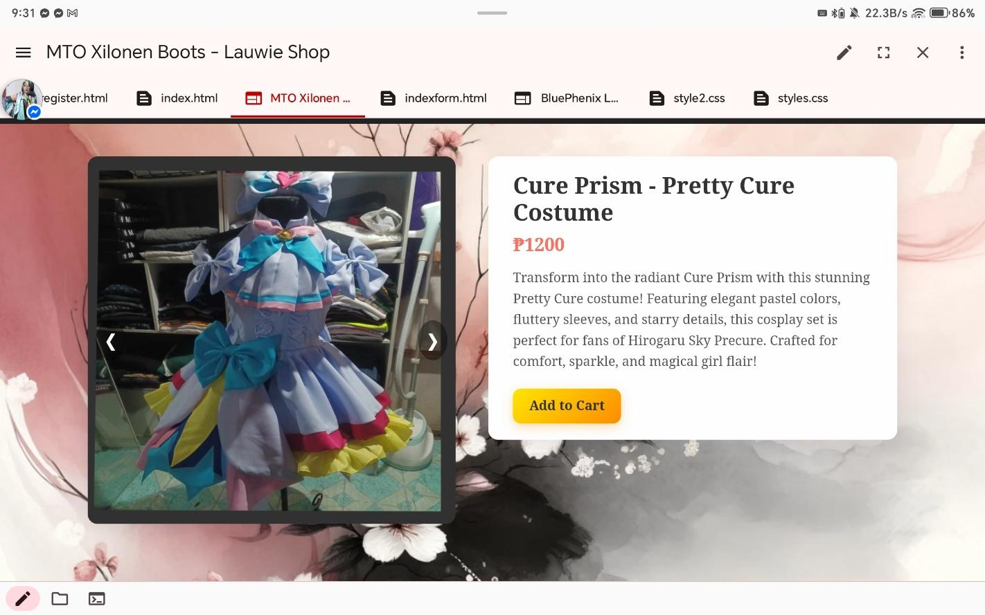

26

I also created and individual page, which you can review the description of the products. Just click the images of the product and you will derive at the description of the product you want

 to buy. This page is designed to help customers view product images, read descriptions, and make a purchasing decision. At the top, the site features a navigation menu with links to the Home, Shop, Categories, About Us, Contact, and Cart pages, making it easy for users to move between sections of the site.

The main section showcases a product image slider, allowing users to view multiple angles of the item through a responsive carousel. Below the slider is a dedicated panel containing the product name, price, and a detailed description emphasizing its quality, cosplay-readiness, and appeal to collectors and fans.

A prominent “Add to Cart” button is included, which triggers a confirmation modal asking users to confirm their action before adding the product to their cart. Styling is handled within the <style> block, and JavaScript handles interactivity such as the image slider and modal actions. Overall, this page plays a crucial role in giving customers the confidence to purchase by delivering all necessary visual and textual details in a clean, functional design.

27

**My Refinement and Changes of Website Journal**

**PHASE 1-30%**

**Purpose**:

Welcome to Julene Shop, your ultimate destination for high-quality cosplay costumes, accessories, and art merchandise.

We are passionate about bringing your favorite characters to life with premium costumes, handmade props, and exclusive fan art.

Online shopping apps have transformed the way we shop, offering unparalleled convenience and accessibility and making it easier than ever to find exactly what you need.

**Description of the Pages:**

I create a simple design which I want many people to share their craft, arts, MTO, selling of items and more.

This can help to achieve and invest easier for the seller.

The user can access the website by scrolling and searching for what they want and need.

**How I created the website:**

I created a simple page which I need to put the title of my header (Home, About us, Contact). I also included my original logo which is Julene Online Shop.

I searched a photo which I can used them for my online shop items. I created my background and I chose light color to be calmer and eye catching’s.

**Need to the website:**

-Alignment (Header and Footer)

28

-Logos (The logo must be at the left side)

-I change the name of the website and the logo which some one already taken the name “Julene Shop”

-Color Combination (Change the background)

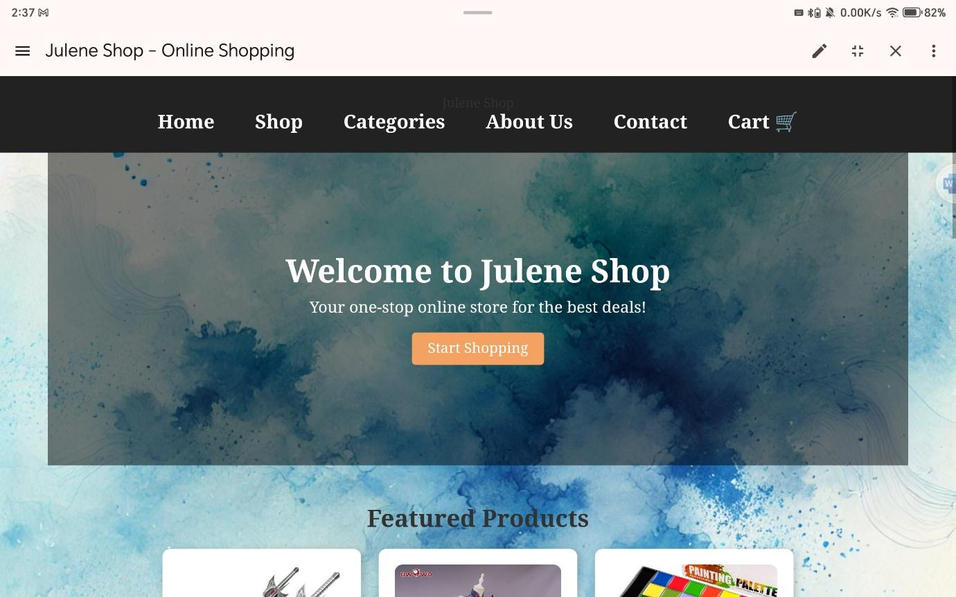

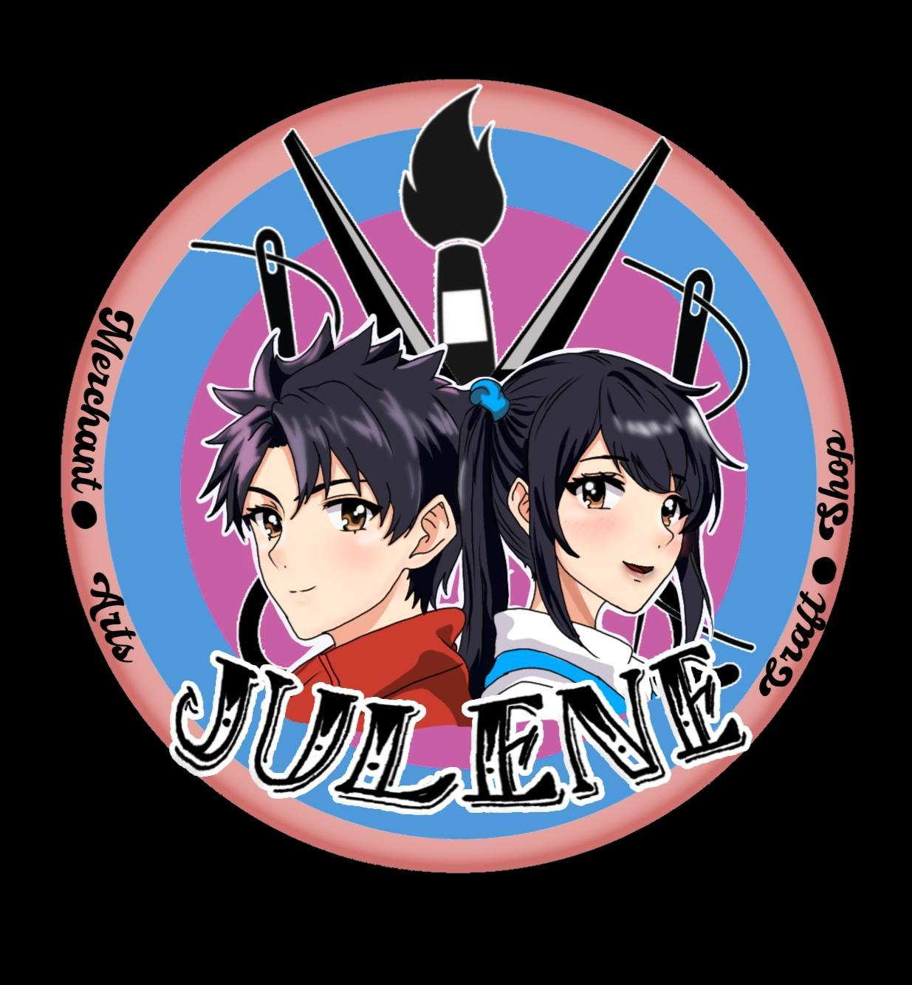

29

**PHASE 2-50%**

In phase 2, I change my logo which is the name "Julene Online" has already taken. I chance the name into "Lauwie Online Shop"(This is my original business page in FB).

I created five website which is Index (Home), Shop, Categories, About Us, Contact, and Cart. I make them Accessible which the user can click each of the header or the nav-links.

I also included the footer when did I created my pages. I change the margin of my website and make it consistency. I used Scroll tools to my responsive design.

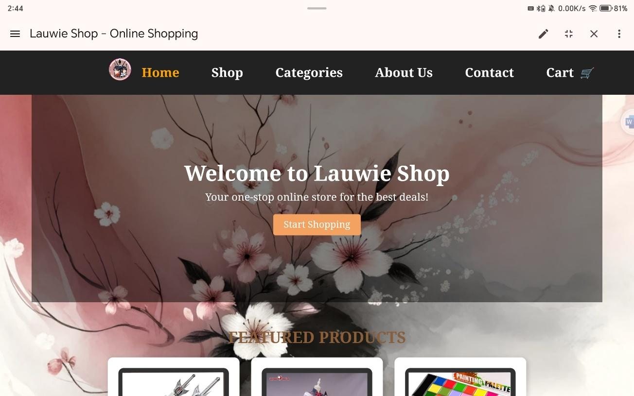

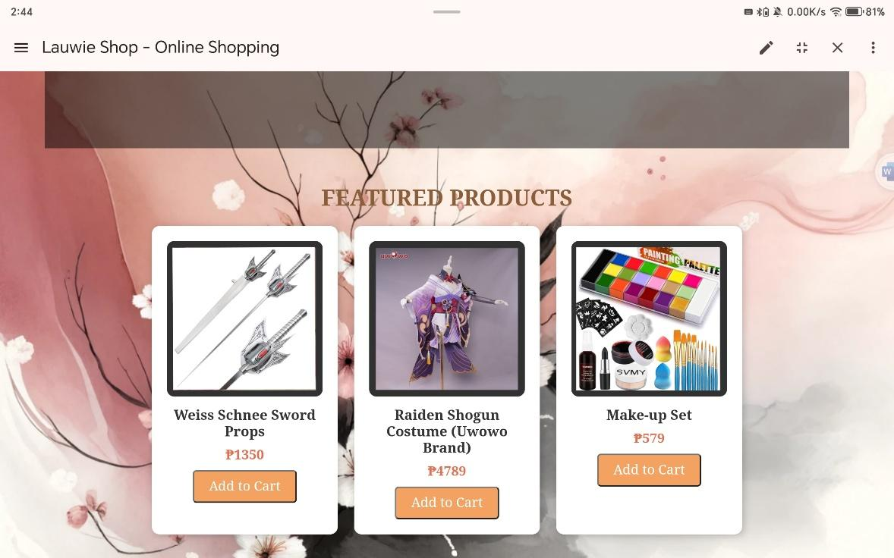

30

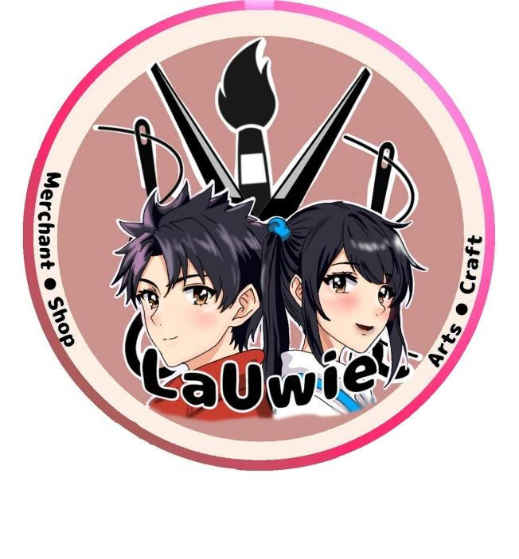

**Need to the website:**

-Color Combination of the text

-The Nav-links Should be at the center

-Change scroll of the header

-Highlight the cart (glowing or moving cart)

31

**PHASE 3-75%**

In phase 3, there are so many changes. I changed the color combination of the text which it cannot be readable by the user, center nav-links. Change my responsive design, and the cart must be highlighted if the user clicks the "Add to Cart" Button.

I change the color of the text and I also put the highlight which the user can read it properly. The responsive design is now adjustable which any kinds of platform will adjust the website to its screen.

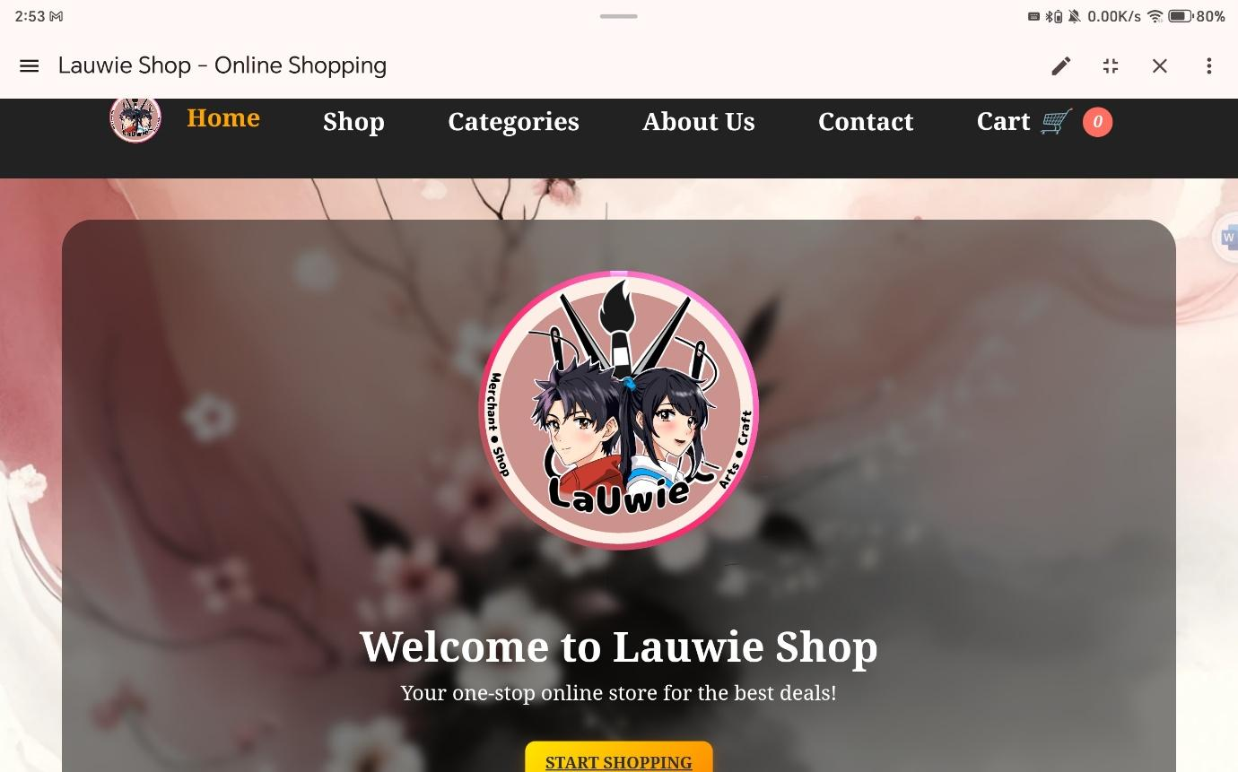

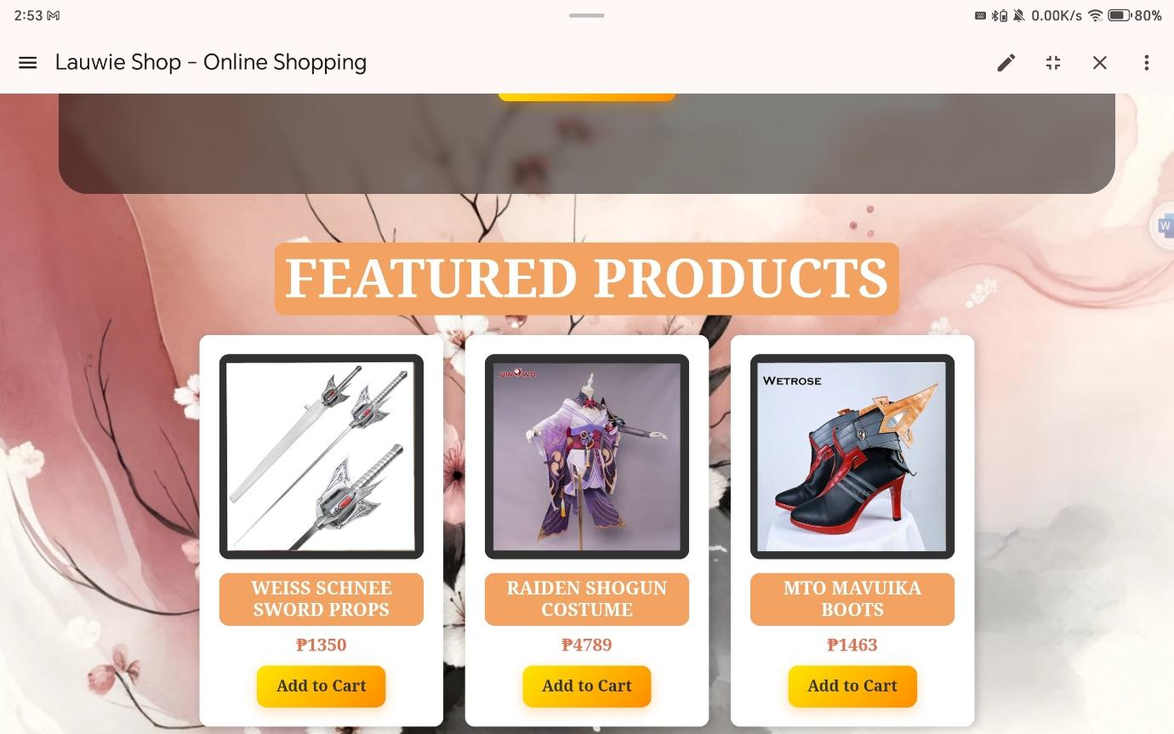

32

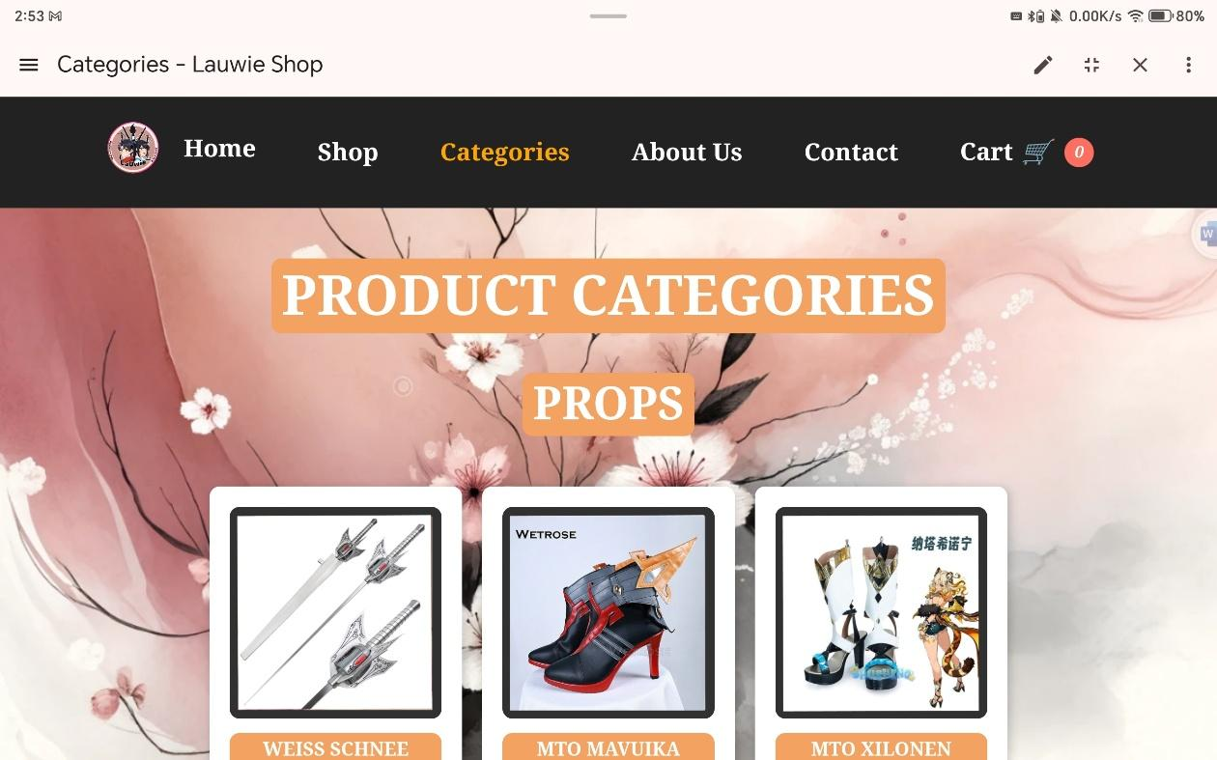

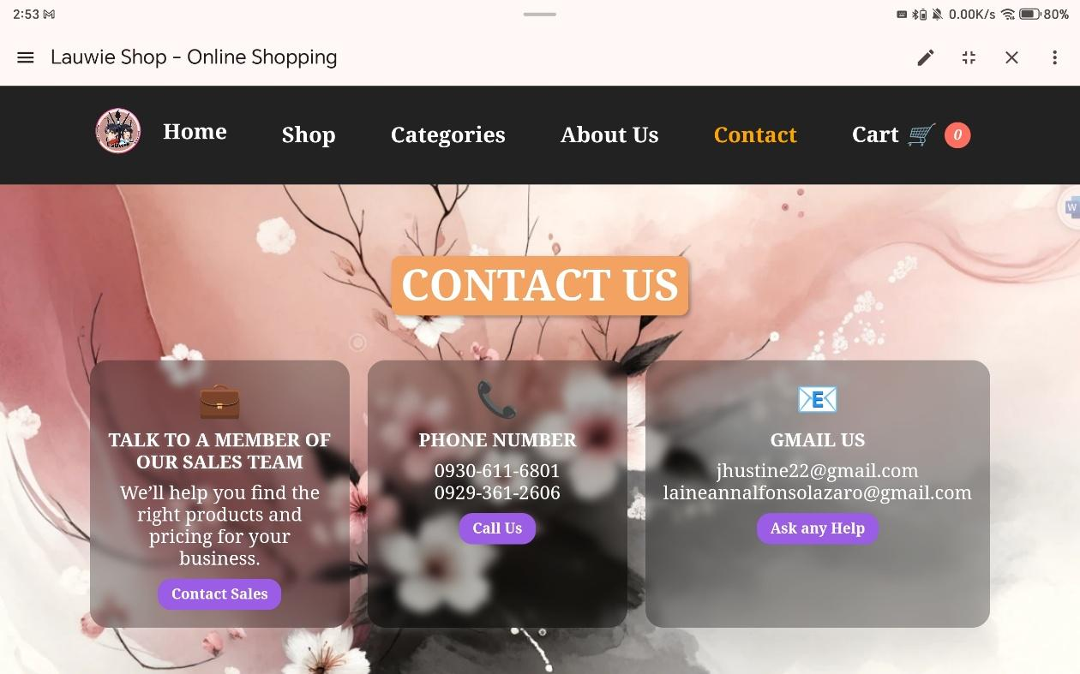

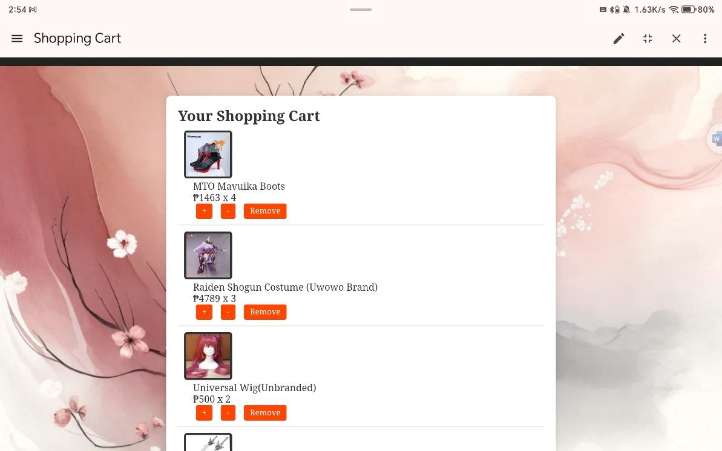

33

**Need to the website:**

-name of the folder (PROJECT_LAZARO FOLDER).

-Lower the black container.

-Put the logo at the nav-links.

-The picture of the product must be uniform and same size.

-Change the color of the button.

-Spacing at the button.

-Make the header big “Product Feature”

-Light the second mesh background (“About Us”)

-Header “About Us” turn into small

-Mark the icon adjusts (adjust the cart icon to the left).

-Forms/registration

-put some video or animation

- other must be clickable

35

**PHASE 4-90%**

I change I add “Log out” at the header which the user can log out or login again. I created another website which is the register form. Html (I change the folder name into index and the home.html I change the folder name into “Home”. The product picture is not clickable which the user can check about the description of the products. The Contact pages. Html is also clickable which is the “Sale contact” and the “help ask to email”

The Logo at the nav-link, left side at beside from the home (I put the name of the Shop same as the registration form. From the cart.html, I also put video at the website of home.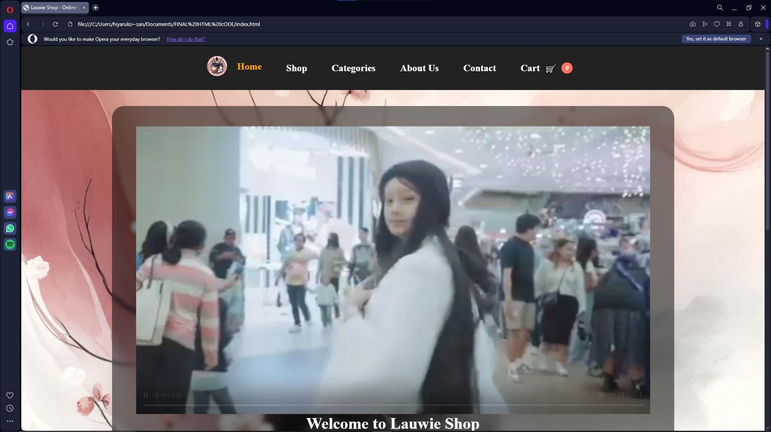

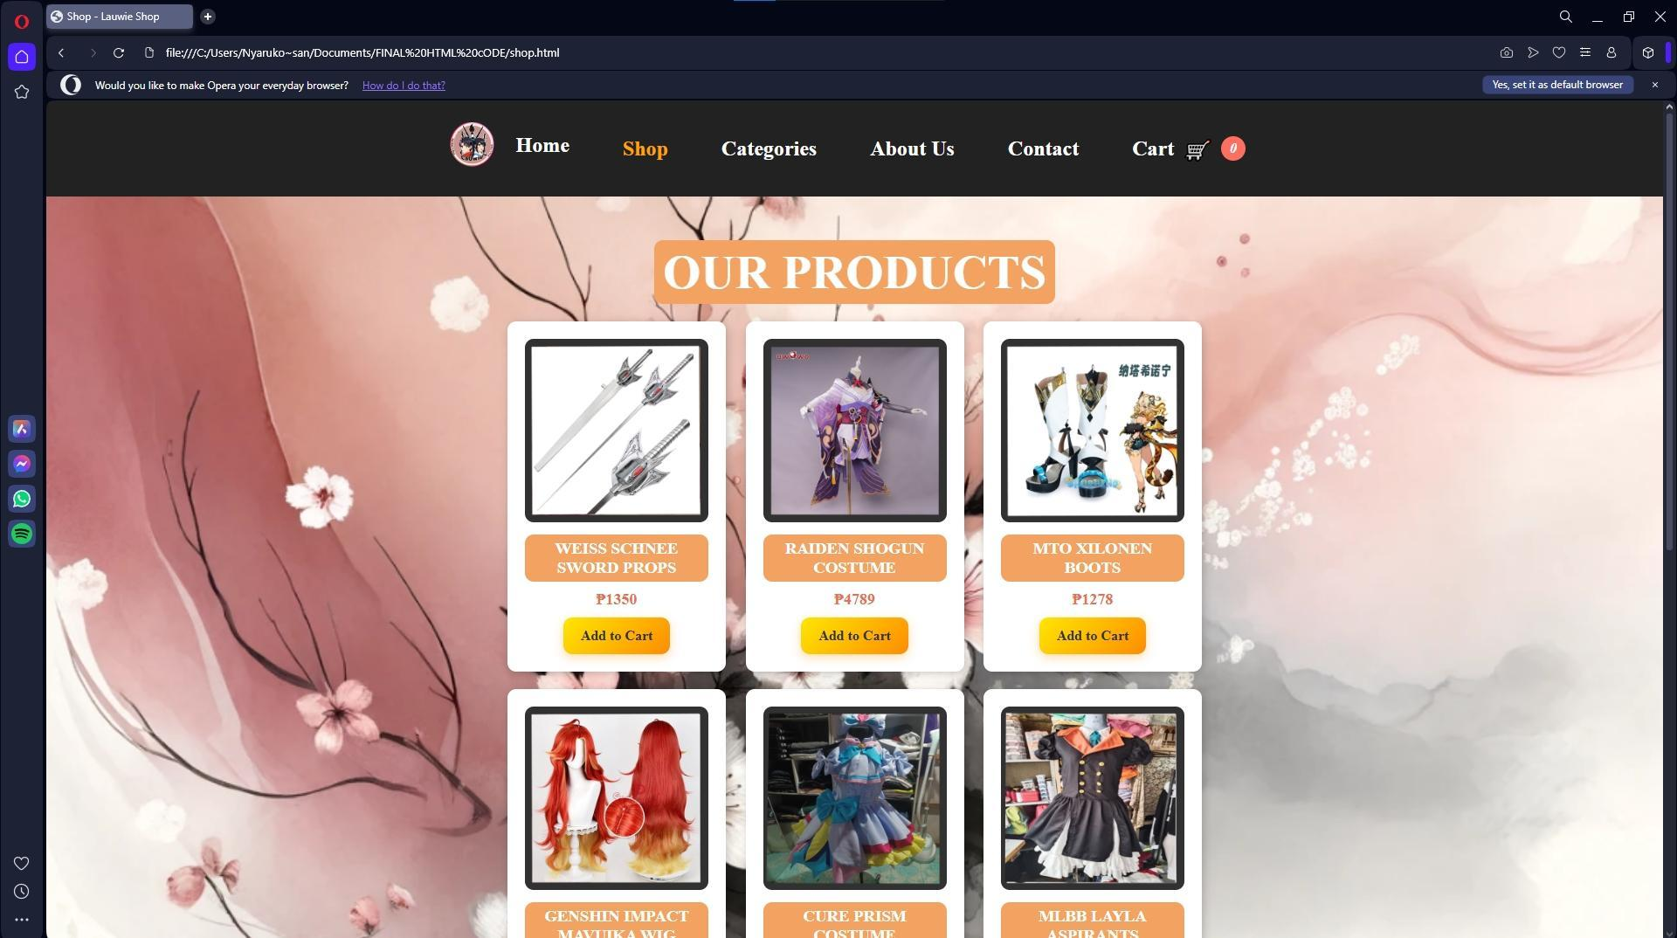

36

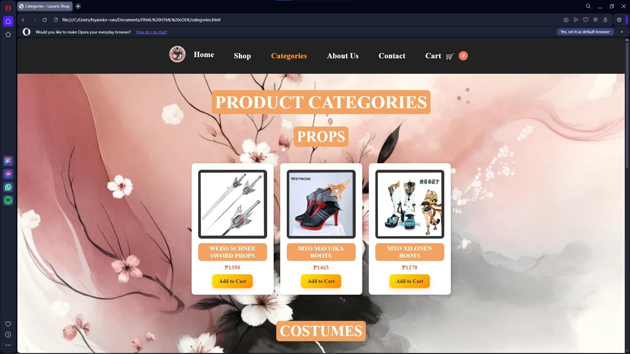

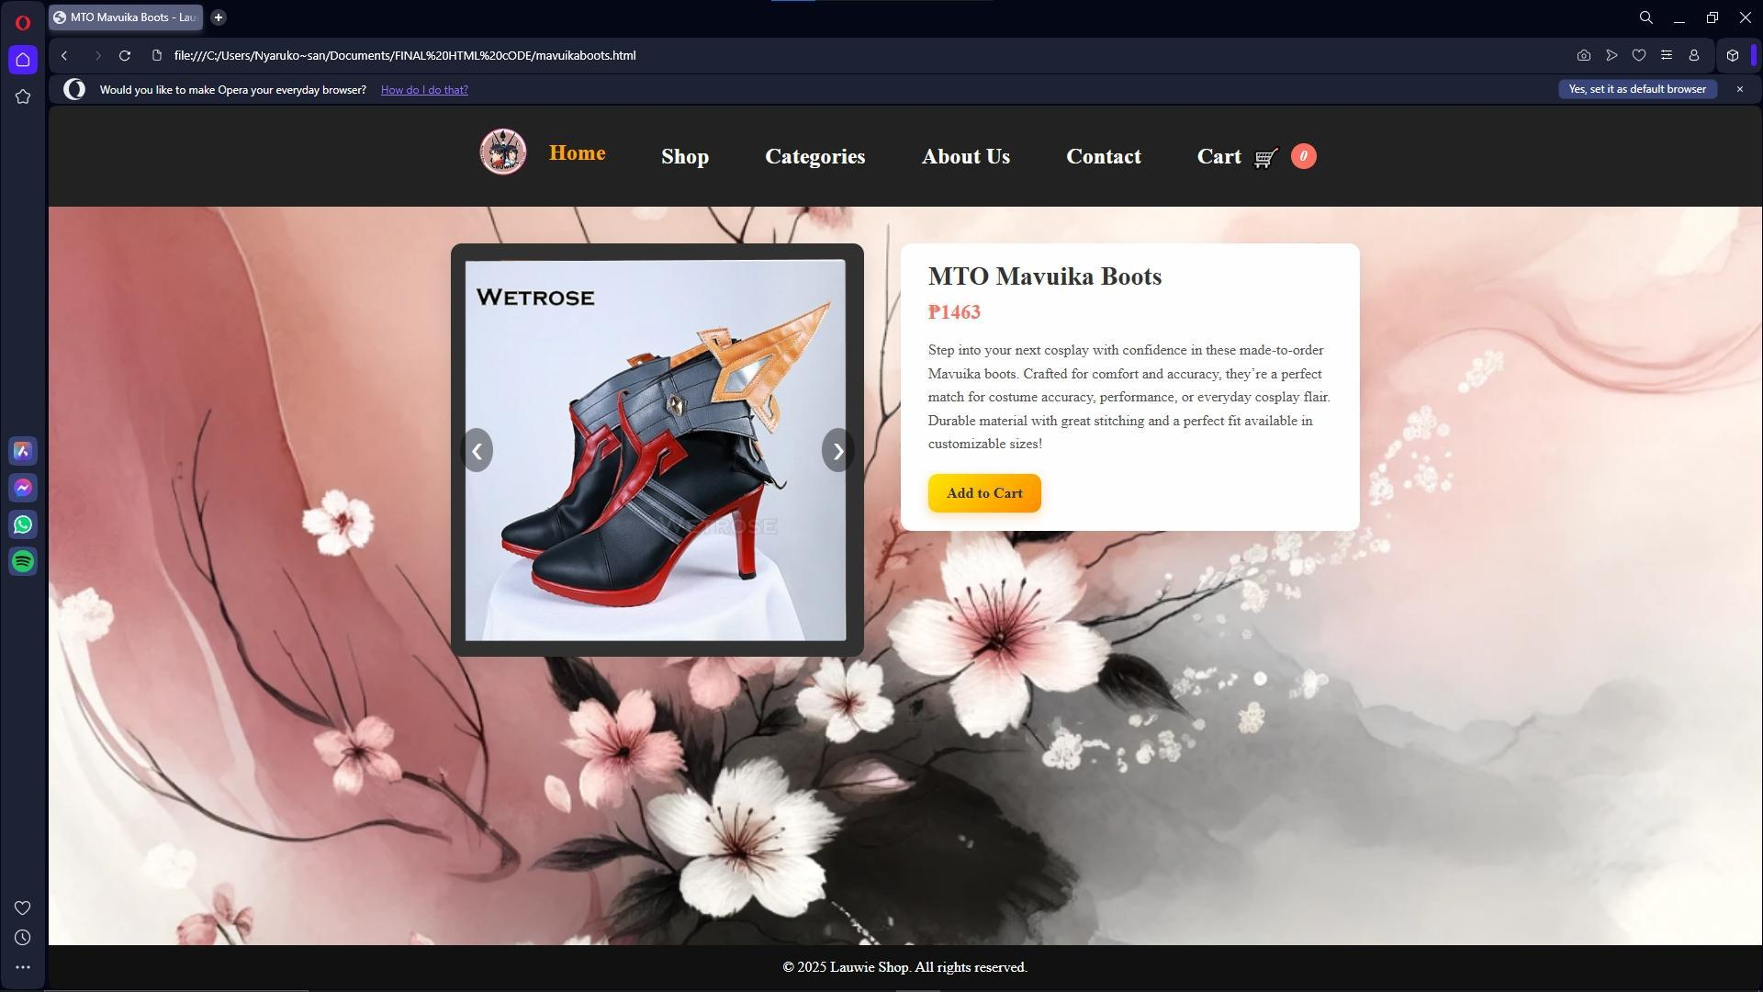

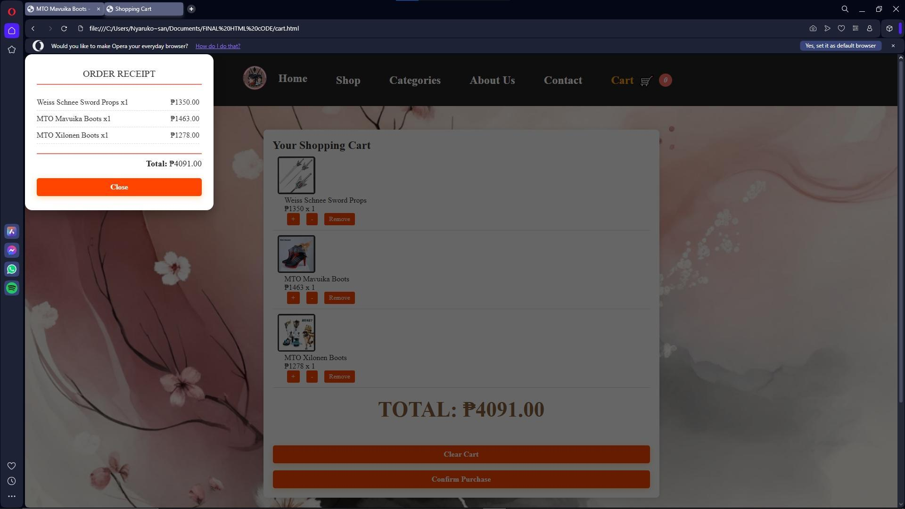

37

**Need to the website:**

-Video have sound.

-The body of the website is scrollable.

-The product description must have the same rectangle container.

-The receipt is printable.

-The register form and login must have a footer.

- The logo at the left side of the nav-link have a name of the shop (Lauwie).

**PHASE 5-100%**

The website and documentation are now completed.



38







39







40







41







42